COMMUNITY DEVELOPMENT WORKER

COURSE facilitator guide

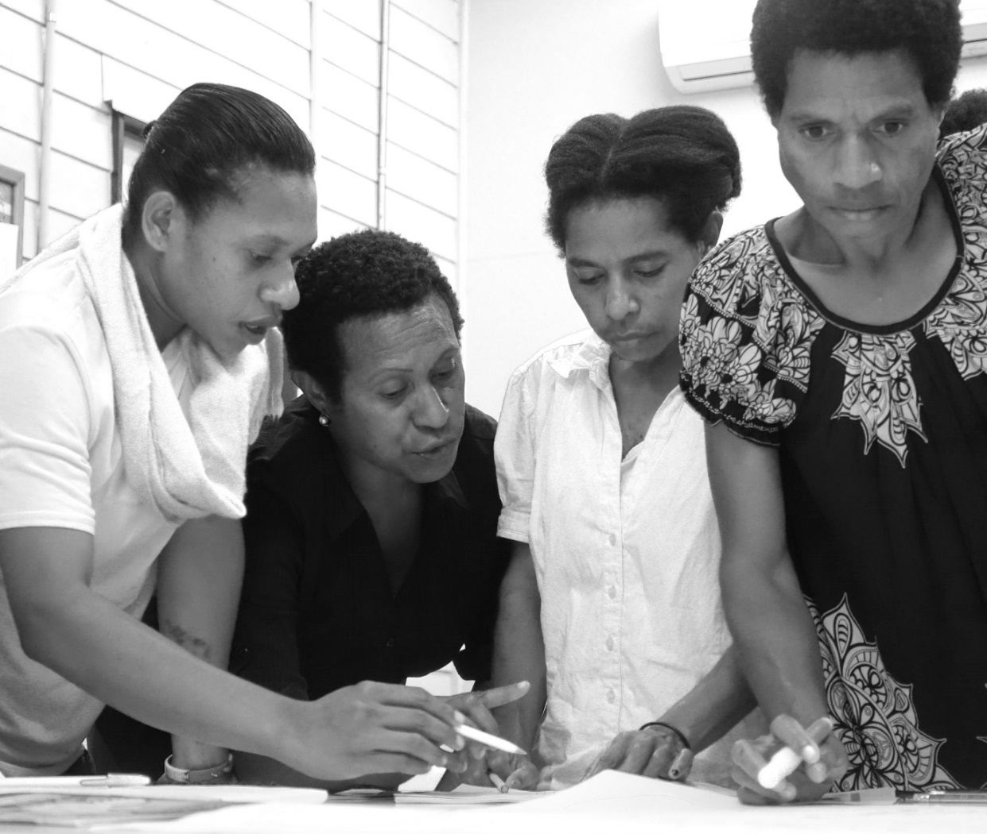

Page 2. Table of contents
Page 3. Information for the course facilitator
Page 8. Answers for CDW Coursebook 1
Make preparations, conduct community entry, and prepare a report
Page 25. Answers for CDW Coursebook 2 “Training and awareness”
Conduct community training and awareness
Page 35. Answers for CDW Coursebook 3 “Participatory planning”
Assist group to analyse their development situation and identify priorities
Assist group to develop a project plan for a community activity
Page 49. Answers for CDW Coursebook 4 “Facilitate agreement and project start-up”
Facilitate agreements for a community activity
Facilitate the start-up of a community activity
Page 60. Answers for CDW Coursebook 5 “Monitoring and evaluation”
Monitor community activity
Evaluate community activity outcomes
Page 71. Answers for CDW Coursebook 6
Provide mentoring
Page 71. Sample answers for CDW Coursebook 7
Facilitate a specialist’s visit
Page 71. Example CDW completion certificate
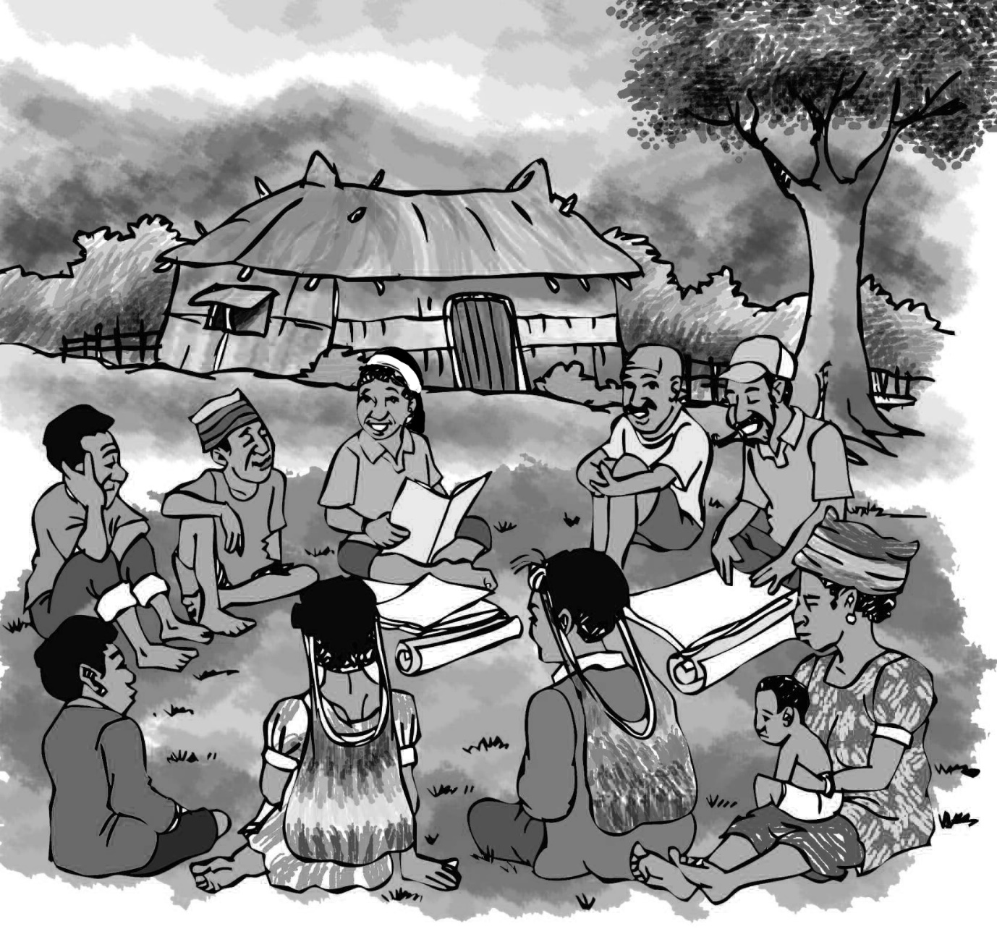


Luk olsem your organisation has asked you to be the course facilitator for the Community Development Worker coursebook series. Luk olsem you have been selected for this role because of your experience. You should have already completed the five Community Development Worker coursebooks yourself. Definitely. If not, then make sure you read through the five Community Development Workers coursebooks very carefully first.

The Community Development Worker coursebook series is for Community Development Workers (CDWs). A Community Development Worker (CDW) is someone who helps communities, groups, families and people in their community. CDWs support community-led development, participatory development, inclusive development, and building local capacity.

CDWs might be people from inside the community. For example, Ward Development Committee or Community Government representatives, grade-12 leavers, youth leaders, Pastors, community volunteers, community educators, women leaders, village liaison officers, and community rangers. CDWs might be people from outside the community. For example, agriculture extension officers, District officers, business development officers, NGO field workers, community affairs officers, or company extension officers. Often CDWs will also have other expert skills. For example, an agriculture extension officer might be an expert on farming systems (a didiman) and also someone who works with communities and groups and families to help them develop (a CDW).

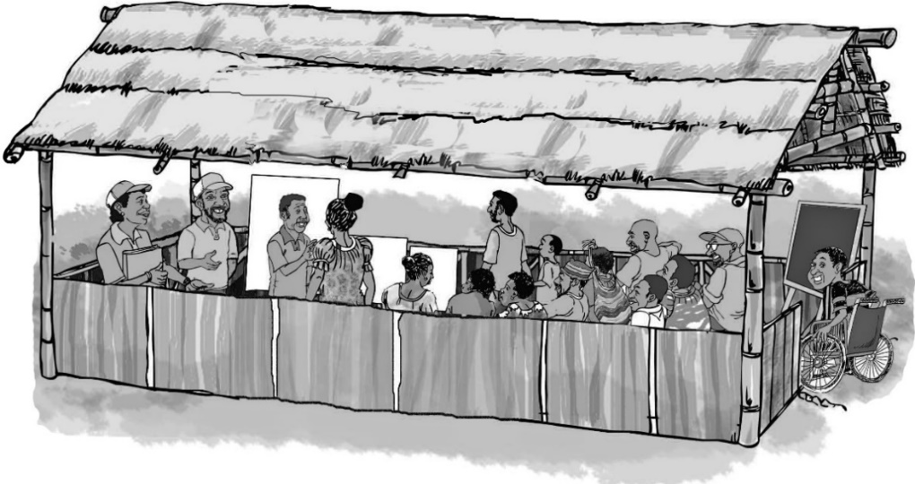

PNG has its own National Standard for Community Development Workers. Bilong yumi yet. Developed by leading PNG CDWs, the National Standard was endorsed by the Government in 2006, under the auspices of the National Apprenticeships and Trade Testing Board (NATTB). The National Standard identifies key jobs and duties for CDWs, then it lists the performance criteria (wok mak) that CDWs need to put into practice if they want to perform those jobs and duties in a way that meets the Standard. You can also be assessed and gain national (Government) accreditation. For more information on the National Standard, go to pngcdwstandard.com or the NATTB website (nattb.org). CDW coursebooks, this course facilitator guide, and assessment information can be downloaded at pngcdwstandard.com. If you have questions, go to pngcdwstandard.com and click on the ‘contact us’ link.

The CDW coursebook series below targets the wok mak from the PNG National Standard for CDWs.  CDW Coursebook 1  Make preparations, conduct community entry, and prepare a report  CDW Coursebook 2 “Training and awareness”  Conduct community training and awareness  CDW Coursebook 3 “Participatory Planning”  Assist group to analyse their development situation and identify priorities  Assist group to develop a project plan for a community activity  CDW Coursebook 4 “Facilitate agreement and project start-up”  Facilitate agreements for a community activity  Facilitate the start-up of a community activity  CDW Coursebook 5 “Monitoring and evaluation”  Monitor community activity  Evaluate community activity outcomes  CDW Coursebook 6  Provide mentoring  CDW Coursebook 7  Facilitate a specialist’s visit | 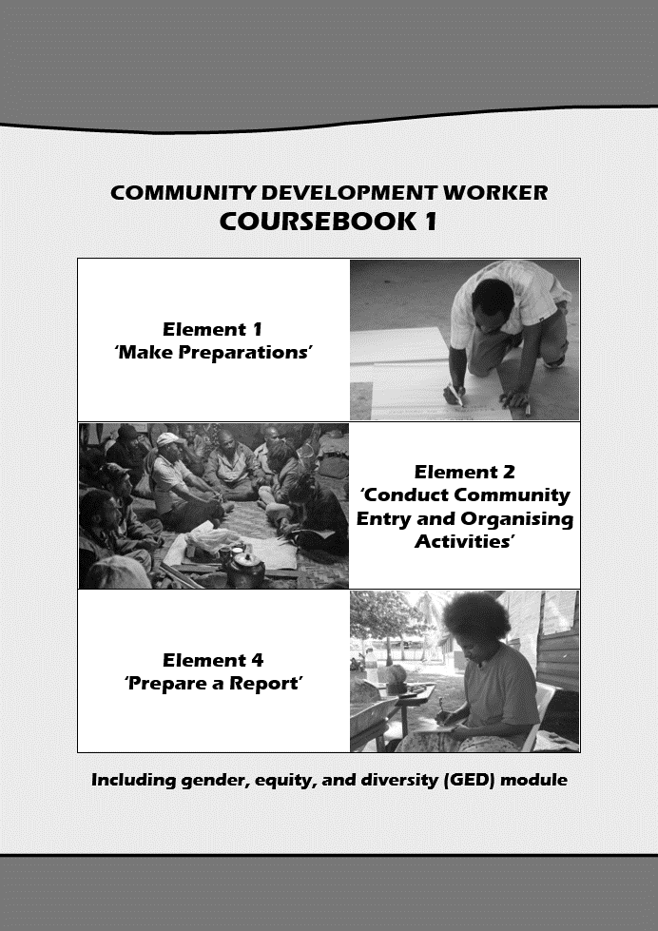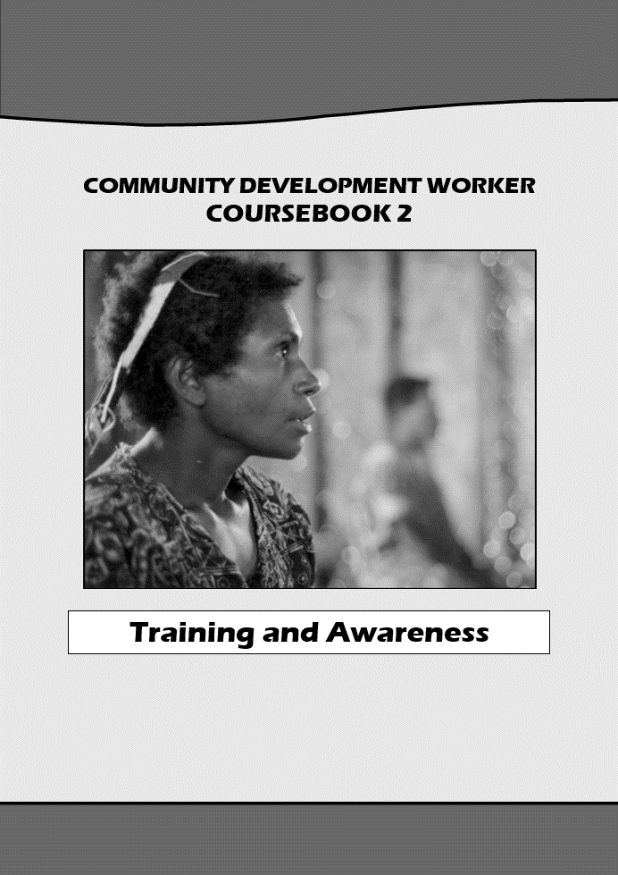  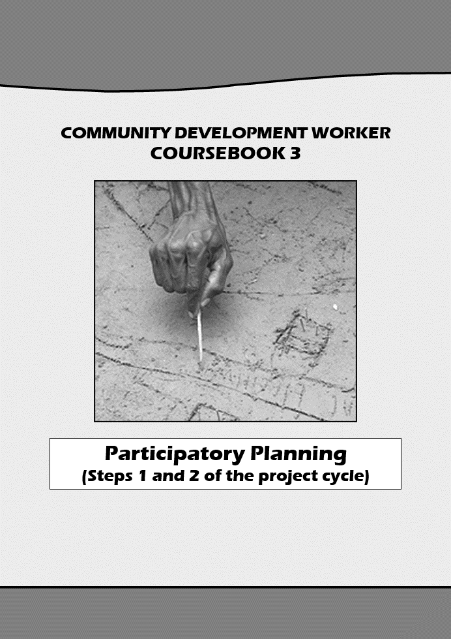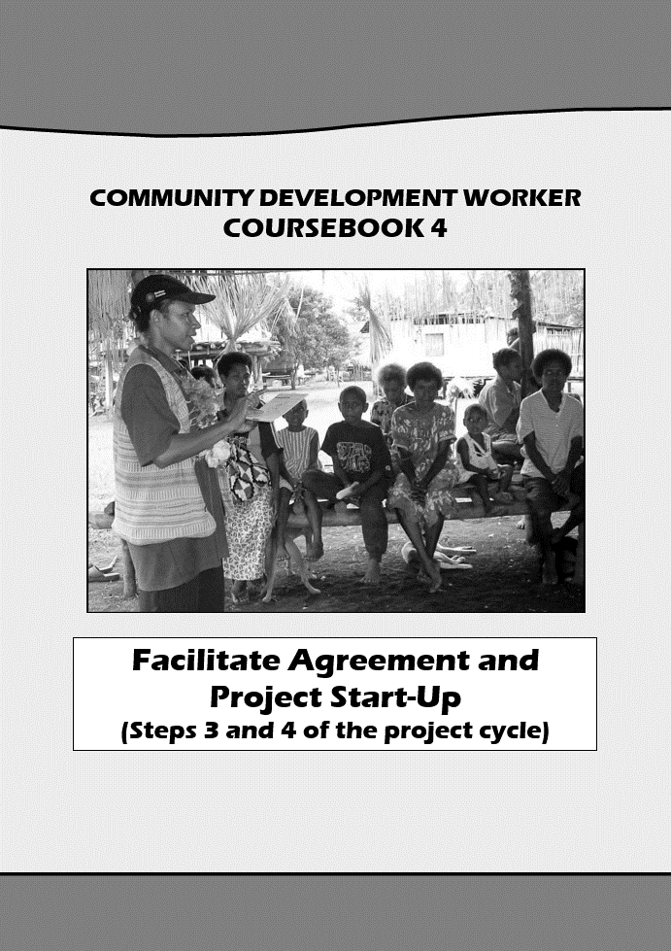  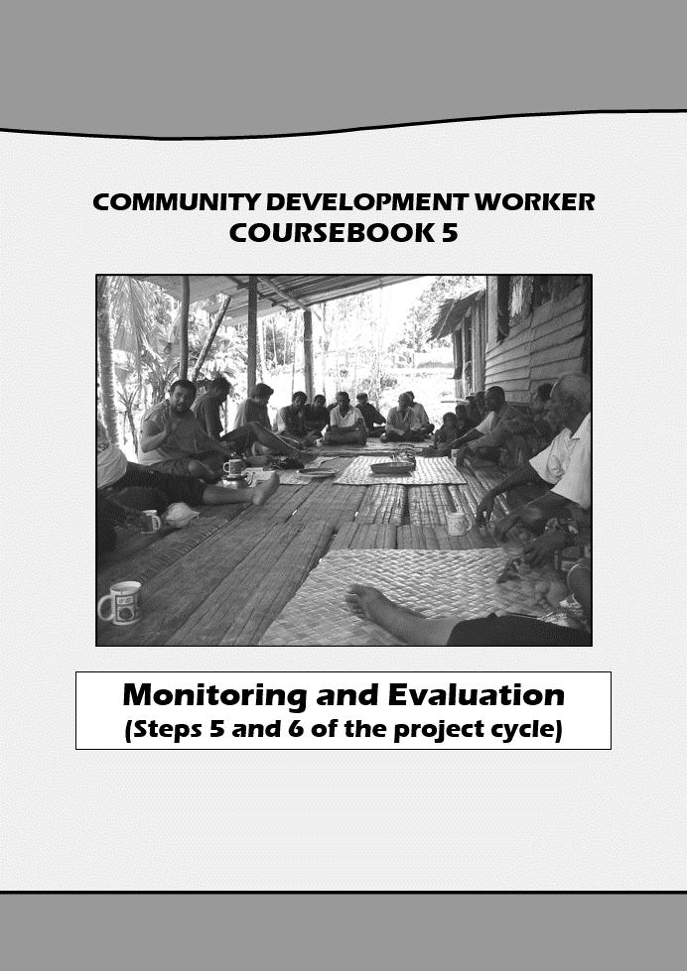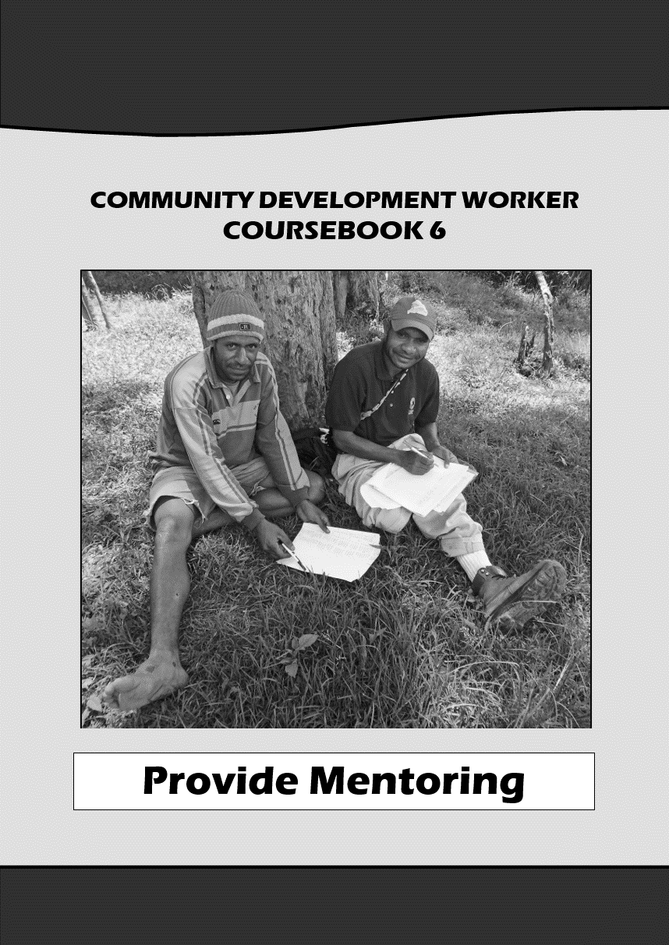  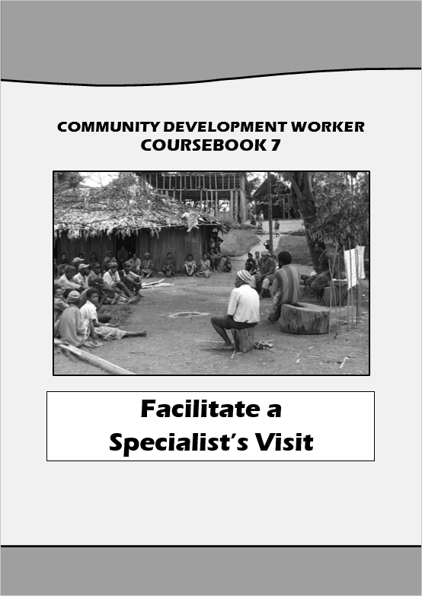
To be a successful course facilitator for the Community Development Worker coursebook series, there are things you need to do BEFORE, DURING, and AT THE END of the course.

BEFORE YOU BEGIN THE COURSE

- Contact each of the course participants, provide them with a copy of the seven coursebooks, and ask them to carefully read through the introduction section of the first coursebook (pages 2-8 in each coursebook).

- Next, help participants draw up a timetable for completing the seven coursebooks. It is best for participants to work through the coursebooks alongside one or more colleagues. Encourage participants to decide who their colleague(s) will be and ask them to identify a regular meeting time to work through the coursebooks together. If the participants have an employer, it is a good idea for their employer to endorse the timetable and support them to follow it. How much time it takes to complete each coursebook depends on the participants and their work situation. A good goal is for participants to try and complete one coursebook per quarter (i.e. every three months). If a participant doesn’t have a colleague to work with, see if they have a suitable friend or family member who wants to complete the coursebooks with them. Or they can complete the coursebooks on their own nogat samting.
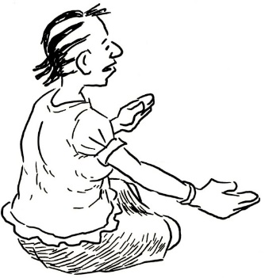
When you help participants draw up a timetable for completing the seven coursebooks, also include how often you (the course facilitator) will check up on them to see how they are going. A good idea is to catch up with the participants once a month. But make sure you also tell the participants that they can contact you ANYTIME they need to.

- Next, confirm that participants understand that they will need to write down their answers to key questions and then send their answers to you at the end. There are a number of key questions in each coursebook that participants need to answer. These key questions say “written answer” at the top, and have a letter of the alphabet (A, B, C…) on the right. Below is an example. When the participant sees a “written answer” question, they will need to write their answer in an exercise book (or a computer). They need to write the letter of the “written answer” question (A, B, C….), and then they need to write their answer. After each coursebook (or at the end of the course) each participant will need to submit their answers to you. Explain that answering these “written answer” questions is not a test. It is not pass or fail. Explain that if they make a mistake, it is your job to help them understand what they have misunderstood.

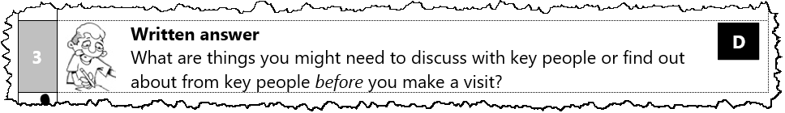

DURING THE COURSE

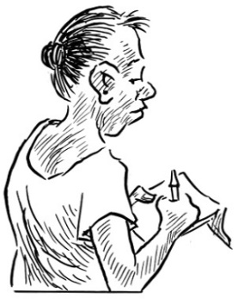
- Catch up with each of the participants once a month. Having someone catch up regularly motivates the participants, it helps them stay on track, and they can ask questions about any misunderstanding they might have. A good idea is to catch up with the participants once a month. If you can, join in one of their regular meeting times, or call them during their regular meeting time and ask the participant you call to put their phone on speaker so that their colleague(s) can also hear you.

When you check up, begin by asking participants where they are up to. Are they on track? If not, why not and what can be done about it? Next, ask them what difficulties they are having? Is there anything that is unclear? If they are having difficulties, then try your best to clear up any misunderstanding. Finally, before you finish, set the time for your next catch up, and make sure everyone agrees on what they are going to try and complete by the time of your next catch up.

AT THE END OF THE COURSE

- Check the participant’s ‘written answers’ and provide feedback. When you check their answers after each coursebook (or at the end of the course), don’t mark them as right or wrong. The purpose of checking their answers is so that you can help clear up any misunderstanding that participants might have.

- Learn lessons from the participant’s evaluation questions (the final “written answer” question in each coursebook is the evaluation question). You (the course facilitator) need to take note of what the participants have written in their evaluation question because it will help you (and your organisation) improve how you facilitate the course. If you need to write a report for your organisation, then you can use this evaluation information to help. If you can, also get in touch with the PNG CDW Industry Technical Committee through the ‘contact us’ link at pngcdwstandard.com and pass on any evaluation information that will help them to improve the course and the coursebooks.

- Issue the participant their “course completion” certificate (if they have completed course requirements). There is a “course completion” certificate you can use at the end of this facilitators guide. This certificate is not evidence that the participant is competent to work in a way that meets the National Standard. Nogat. A completion certificate only shows that the participant has completed the course requirements. To know if the participant is competent to work in a way that meets the National Standard, they will need to be assessed as competent by a CDW Workplace Assessor. For more information on how assessment works, go to pngcdwstandard.com.

Formal training option

The seven CDW coursebooks can also be used for formal training, in which case the seven coursebooks become the participants’ handbooks (and the trainers’ handbooks). Formal training is the best way for participants to learn, but it can be difficult and expensive for organisations to arrange (especially in PNG). If you run the CDW course as formal training, then it is best if you (the course facilitator) work alongside a co-trainer to deliver the training course.

In the seven coursebooks, you will notice that in each topic there are numbers on the left-hand side. These are the steps. Each topic is broken into steps. Step 1, step 2, step 3 igo igo. A step groups together information that is about the same sub-topic. In between each step, there is a footprint to show that one step has finished, and the next step is beginning. Below is an example. If you use the CDW coursebooks as trainer’s handbooks, then as you go through the handbook, you teach one step, and while you are teaching, your co-trainer can prepare to teach the next step. Easy

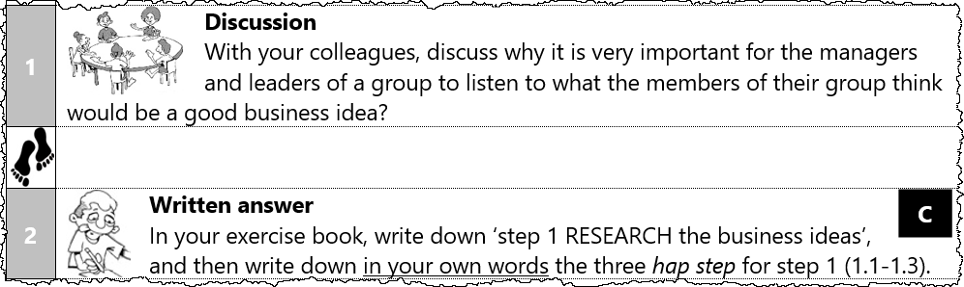

If you run the CDW course as formal training, it takes 4 or 5 days to complete each coursebook, starting at 8.30 in the morning and finishing at about 4 pm. If you do this, then don’t have more than 25 participants (20 is best). If you run the CDW course as formal training, then participants still need to complete the questions and activities. And to complete course requirements, each participant will still need to submit their “written answers” to you (the course facilitator) at the end. To save time, it is a good idea to ask participants to complete the “written answer” questions for homework or in their own time.

Other related training courses for CDWs

If you go to pngcdwstandard.com and navigate to the menu “Other resources for working with wards, communities, CBOs, SMEs, and families” you will find other training coursebooks you can use to help you when you work with a group or community or family. For example, there is training for Ward Development Committees to show them how to do ward priority planning (ward development planning), a training series on how to help a business group develop a business plan, a training series on how to help build the capacity of a community organisation, and a training on financial literacy for families (family money management). For more information, go to the website and click on the ‘contact us’ link.

Sample written answers for CDW Coursebook 1

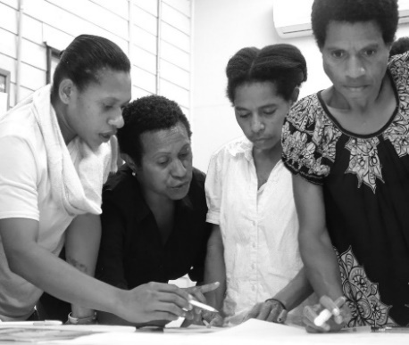
Below are the “written answer” questions from CDW coursebook 1. Underneath each question is an example of a good answer. Don’t forget, this is not a test. If a CDW has made a mistake or has a different answer, then it doesn’t mean they have failed. If they have tried their best to answer every question, then fine. But you definitely need to give feedback to the CDW, so they learn from their mistakes. The best way to do this is to meet with them and go through their answers one by one. If you can’t meet with them, then give them feedback on the phone or online.



2 |   Written answer  A  What is a National Standard? Discuss this with your colleagues. Next, in your exercise book, write your answer.

A good answer from a CDW is something like the following:

- A ‘National Standard’ is an official document which makes it clear what you need to do to meet the nation-wide standard for a job.

4 | Written answer  B  With your colleagues, write the coursebook objective on a poster na putim long ples klia. Leave it long ples klia until you complete this coursebook. For coursebook 1 (this coursebook) the objective is to Understand how to make preparations, conduct community entry, and prepare a report in a way that meets the Standard. Next, in your exercise book, write the coursebook objective in big letters.

A good answer from a CDW is:

- Understand how to make preparations, conduct community entry, and prepare a report in a way that meets the Standard

4 | Written answer  C  Think about your own workplace. List three different ways you can find out information about the place and people that you are going to visit?

A good answer from a CDW will probably include three of the following ways to find out information, but if they come up with other ideas then even better:

- Talk to people who are from the place to be visited
- Talk to friends or colleagues who know about the place you will visit
- Telephone or contact in some other way key people from the place to be visited and ask them questions
- Check reports or other written information about the place and people to be visited

3 | Written answer  D  What are three things you might need to tell key people before you make a visit? What are three things you might need to find out about from key people before you make a visit?

A good answer from a CDW will probably include three of the following things to tell key people before you make a visit, but if they come up with other ideas then even better:

- Why you are coming (hopefully they know already because they asked you to come)
- If there is anything sensitive about what you plan to do
- How many people will be coming
- When you plan to come
- How long you plan to stay
- What support you will need
- Your contact details
- What your expectations are

A good answer from a CDW will probably include three of the following things to find out about from key people before you make a visit, but if they come up with other ideas then even better:

- Whether they want you to come
- Whether the timing for the visit suits the group or community
- Whether they agree with your work plan (the activities)
- What their expectations are for your visit
- What you need to know or bring so that you stay safe and healthy

2 | Written answer  E  Imagine that you need to prepare a work plan for a short visit to carry out some community development work (you choose). Don’t worry about including a budget (pretend in your organisation your Line Manager is responsible for preparing the budget after you give them your work plan). Don’t forget to put a copy of the work plan that you and your colleagues come up with in your exercise book.

In their exercise book, the CDW should have included a work plan. There are lots of ways to do a work plan, but it should include the following information:

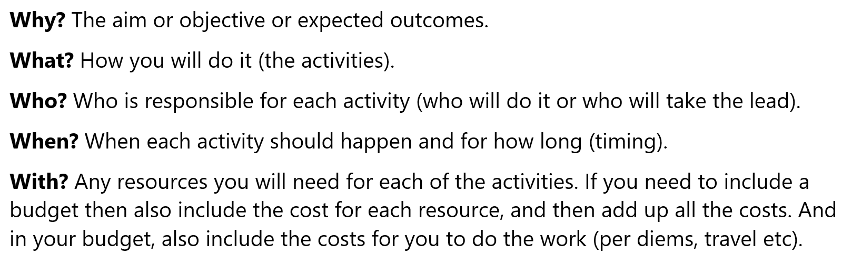

3 | Written answer  F  Look at the work plan below. With your colleagues, list the materials that you think you will need for day three? The materials for day three should be suitable (they should suit the participants and they should suit the work plan). And don’t forget that it is a great idea to use local materials wherever possible. When you have finished, don’t forget to write what you come up with in your exercise book.
  awareness with gogol community on handwashing
  WHY? | Objective: Gogol community have better hygiene.  Expected outcomes: (1) Participants understand why and how to wash their hands properly. (2) The Ward Development Committee can deliver the same awareness themselves.
  WHAT |  | WHO | WHEN | WITH
  Day one. Arrive in Gogol. Remote community two days walk from road |  | Bennie | Monday 13th
  Day two. Meet with Ward Development Committee and other key people to organise the activities and plan who does what. |  | Bennie and Ward Development Committee/key people | Tuesday 14th  A few hours. Walk around Ward to see.
  Day three. Deliver awareness in Nambawan village. See the plan for the awareness (below). Bennie takes the lead. |  | Bennie and Ward Development Committee | Wednesday 15th  Should take 3 hours.
  Day four. Ward Development Committee deliver awareness in Nambatu village, supported and mentored by Bennie |  | Ward Development Committee and Bennie | Thursday 16th  Should take three hours.
  Day five. Final meeting with Ward Development Committee and other key people to discuss the rollout of the awareness and how it will be put into practice. Set time for a follow-up visit. Depart in the afternoon. |  | Bennie and Ward Development Committee/key people | Friday 17th
  Plan for the awareness
    - INTRODUCE. Start by introducing the importance of good hygiene and washing your hands properly. Let the participants discuss themselves why it is important. What happens if you don’t have good hygiene. Share stories. Identify which diseases are spread by poor hygiene.
    - EXPLAIN. Explain why washing your hands with water gets rid of germs. Explain why if you use soap it is even better (what does soap do that is better than just water on its own).
    - DO. Show people how to wash their hands properly with water. Then show them how to do it with soap. Then get some participants to have a go at doing it themselves.
    - REVIEW. Go over what we did in the awareness. Let everyone discuss the importance of washing hands properly in Gogol community. Give out butcher paper and markers and get everyone into small groups to design posters that can be put up around the community. Also, get everyone to come up with an action plan for how the community can put the awareness into practice.

A good answer from a CDW will probably include some of the following materials for day three, but if they come up with their own ideas even better (as long as they are suitable):

- A bucket or large container for washing hands in
- Soap
- An example poster of washing hands (which uses pictures and is at the right level and local language)
- Butcher paper and markers

4 | Written answer  G  If you work for an organisation, then with your colleagues, list all the workplace health and safety policies and practices that you need to follow when you prepare for a visit (in the office or at home). Next, list any other workplace policies that you need to follow when you prepare for a visit (in the office or at home). Use this information to guide you next time you prepare for a visit. Don’t forget to put a copy of what you come up with in your exercise book.

A good answer from a CDW will list all of their most important office-based health and safety policies and practices (as the course facilitator you may need to check up on what the CDWs office-based health and safety policies and practices are). If the CDW doesn’t work for an organisation, then they don’t need to answer the first part of this “written answer” question (unless as a freelance they have their own policy). The CDW also needs to list any other workplace policies they need to follow when they are preparing for a visit (in the office or at home). A good answer from a CDW will probably include some of the following things that they can do themselves to stay safe and healthy when they make preparations:

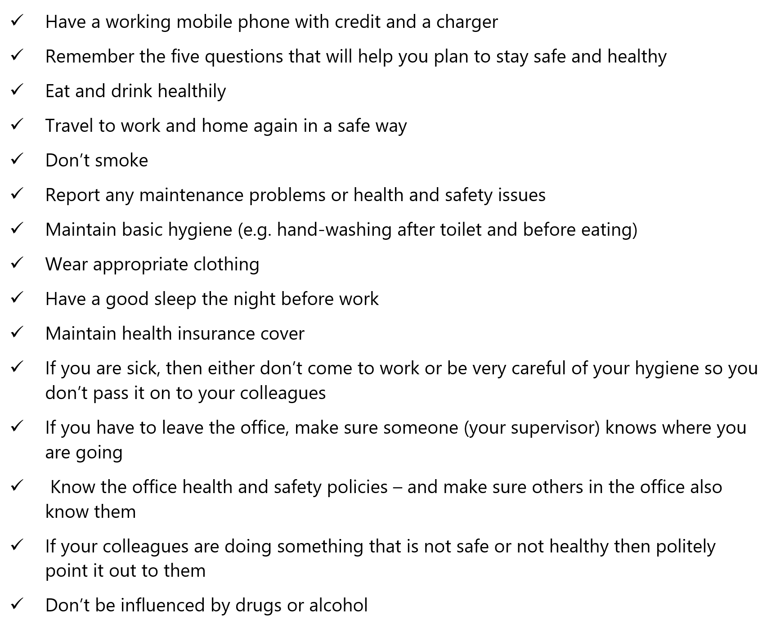

Written answer
H
With your colleagues, read the case study below and then answer the questions that follow. Don’t forget to write your answers in your exercise book.

Dylan is a Community Development Worker for a small NGO called Niupela Sankamap. Niupela Sankamap helps disadvantaged communities make use of local resources and find local solutions to improve their standard of living. Niupela Sankamap has a one-room office in a converted shipping container. There are computers, a printer, a phone and VHF radio. The office also has a tap, sink and kettle. Making a cup of tea in the morning, Dylan notices that the socket sparks when the kettle is plugged in. After making his cup of tea Dylan unplugs the kettle and gets on with his work.

Dylan has been asked to carry out drug and alcohol awareness at Doma. Doma community is located about two hours walk from the main access road. Doma has a population of 360 people. It is a traditional community where a chief system is strong. One of the major problems is poor law and order. Many attempts have been made to improve law and order, but these seem to have failed. David, a colleague of Dylan’s, has been to Doma to conduct community mapping and needs analysis, but has since left work, and lives far away. Dylan has not read David’s report.

Dylan knows a man from Doma who lives nearby. When people from Doma come to town they usually stay with that man. There is a catholic mission in Doma and Dylan’s boss has told him that the mission can be contacted by mobile and by VHF radio.

Dylan knows that Doma is usually a two-hour walk from the nearest road. Dylan has heard a rumour that the walking track has been damaged by a big landslide and that tribal fighting has started in a neighbouring area.

Discussion questions:
- How could Dylan find out information about Doma before he visits?
- What are some of the things Dylan should try to find out before he visits?
- How could Dylan find out who the key people are to communicate with?
- What are at least two ways Dylan could get in touch with key people at Doma?
- What information should Dylan communicate before he visits?
- What could Dylan have done to improve the safety of his office workplace?

A good answer from a CDW will include answers like the following:

- How could Dylan find out information about Doma before he visits?
Dylan could try and call David to find out more information about Doma. Dylan should also read David’s report. Dylan can talk to the person from Doma who lives nearby. Dylan can call the catholic mission to find out more information.
- What are some of the things Dylan should try to find out before he visits?
How the visit by David went (was there any problems)? If the walking track is okay? If tribal fighting is a problem (safety)? What the law and order situation is like (safety?) Does the Doma community still want the drug and alcohol awareness? Does the chief support the awareness?
- How could Dylan find out who the key people are to communicate with?
Dylan can ask David (call him) and check his reports. Dylan should also talk with the person from Doma who leaves nearby. Dylan can call the catholic mission and ask the priest who the key people are to communicate with.
- What are at least two ways Dylan could get in touch with key people at Doma?
Through the catholic mission VHF radio. He can also ask the priest at the catholic mission to give his phone number to the key people (or ask for their phone numbers). He can ask the person from Doma who lives nearby for the phone numbers of the key people.
- What information should Dylan tell the key people or find out from the key people before he visits?
What the awareness is about. When he is coming. Who is coming. How long he will be staying. What he will need during the visit. What his expectations are of the community. What the communities expectations are of him. If there are any health and safety issues.
- What could Dylan have done to improve the safety of his office workplace?
Notify his line manager that the electrical socket needs to be fixed and cannot be used. Place a ‘don’t use’ sign over the electrical socket.

4 | Written answer  I  What is one reason why it is important to confirm who the key people are when you arrive in the community to do community entry?

A good answer from a CDW will include one of the following answers (or similar):

- It may be that you have been misinformed about who the key people are, or it may be that some key people are not present, or there may be other key people that you did not know about.

7 | Written answer  J  Pretend that you and your colleagues are conducting awareness about a new District grant (funding) opportunity for people wanting to start a business. During community entry (Element 2) a wok mak you need to perform if you want to meet the Standard is ‘discuss roles, expectations, and the purpose of the visit with key people’. With your colleagues, go back over the topic and make sure you are clear about what you need to talk about with the leaders and key people if you want to meet the Standard. When you have finished, write down what you would say to the leaders and key people to lower their expectations (about the new district grant [funding] opportunity for people wanting to start a business).  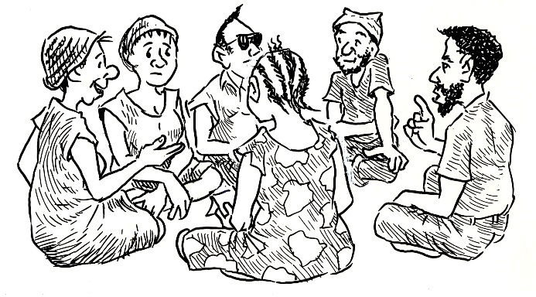

A good answer from a CDW is something like the following:

- Luk olsem it won’t be easy for people to get funding for their business. Ino isipela samting. It will depend on how good your business plan is. I am not involved with making decisions about who gets funding for their business.

10 | Written answer  K  In this topic we looked at THREE BIG REASONS why it is important for as many people as possible to participate in community development activities – not just leaders and key people (participation). And we also looked at THREE BIG REASONS why encouraging and supporting inclusion is important. In your exercise book, write down the three big reasons for encouraging and supporting participation AND the three big reasons for encouraging and supporting inclusion.

A good answer from a CDW is something like the following:

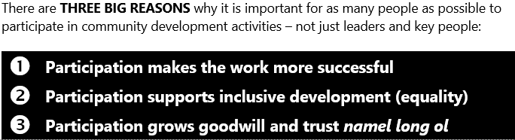

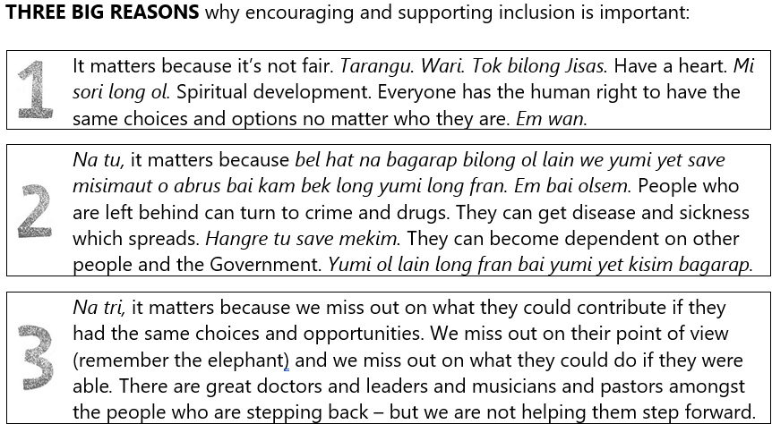

5 | Written answer  L  With your colleagues, discuss what you need to do to communicate with key people in a way that meets the Standard. Next, in your exercise book, write down three things you are going to try and do next time you conduct community entry so that you communicate more effectively and respectfully with key people.

A good answer from a CDW will probably include three things from the following list, but if they come up with other ideas then even better.

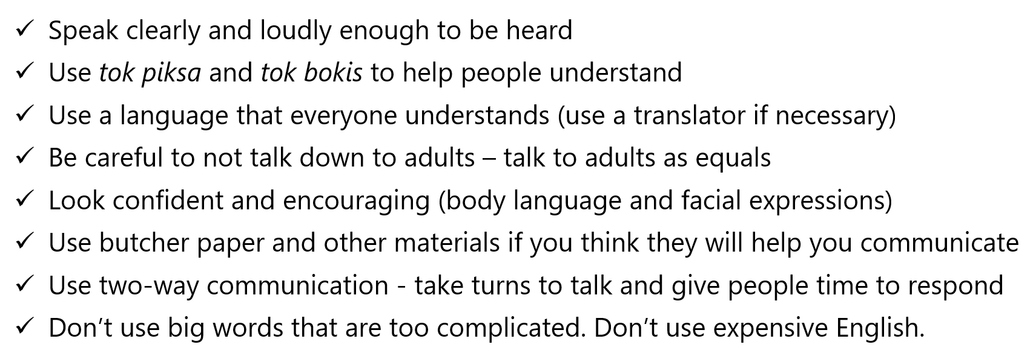

1 | Written answer  M  Doing community entry properly is one way to show respect for local culture. In your exercise book, explain how doing community entry properly shows respect for local culture?

A good answer from a CDW is something like the following:

- In our PNG culture it is very important before you begin to sit down with people, talk, get to know each other, na putim olgeta samting long ples klia. Pasin.

3 | Written answer  N  With your colleagues, discuss what you would say to key people to explain why it is important that both men and women are involved in decision making. Next, in your exercise book, write down the six big reasons (above) why yumi PNG yumi nidim stret women to also participate in decision making. Raitim gut.

A good answer from a CDW will include the following six reasons why yumi PNG yumi nidim stret women to participate in decision making:

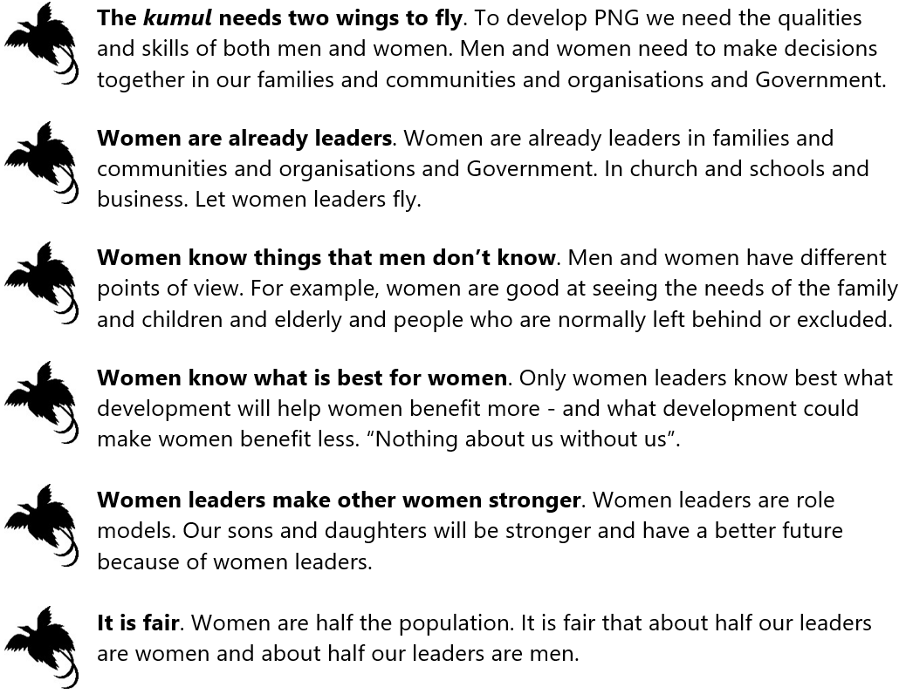

2 | Written answer  O  With your colleagues, read the case study below. In Element 1 topic 1.3 ‘How to prepare a suitable work plan’, you looked at a work plan prepared by David and Mary. They were planning to make a visit to Ward 12 to help evaluate their Ward beautification project. Tingim. The work plan that David and Mary prepared is included again on the next page. Below is a page from Mary’s journal which she wrote after arriving in Ward 12 to conduct community entry. Luk olsem David and Mary found that things had changed. If you were David and Mary, what changes would you make so that the work plan and materials for the activities will still be suitable? When you have finished, write your answer in your exercise book.  Monday 23rd  David and I arrived today as planned. Everyone knew we were coming and everything was ready. Ward 12 youth group met us at Apim bridge and escorted us the rest of the way. We spent the first night with Pastor Jack’s family. Pastor Jack said that from his point of view the Ward Beautification project has been a great success. On the first night, we wanted to play a movie for Pastor Jack’s children, but Pastor Jack said that the only generator in Ward 12 was no longer working. We also found out that a leader in Saksak village was very sick and the Pastor thought he might die soon. The Ward Development Committee Chair, Ward Member Basil, arrived in the evening to welcome us. He recently returned from a Seventh Day Adventist kibung in town (along with his sister who is also on the Ward Development Committee). We didn’t realise that the Seventh Day Adventist church was strong in Ward 12. All in all a great first day. Tomorrow David and I are going to meet with the Ward Development Committee and other leaders to continue organising the evaluation activities.  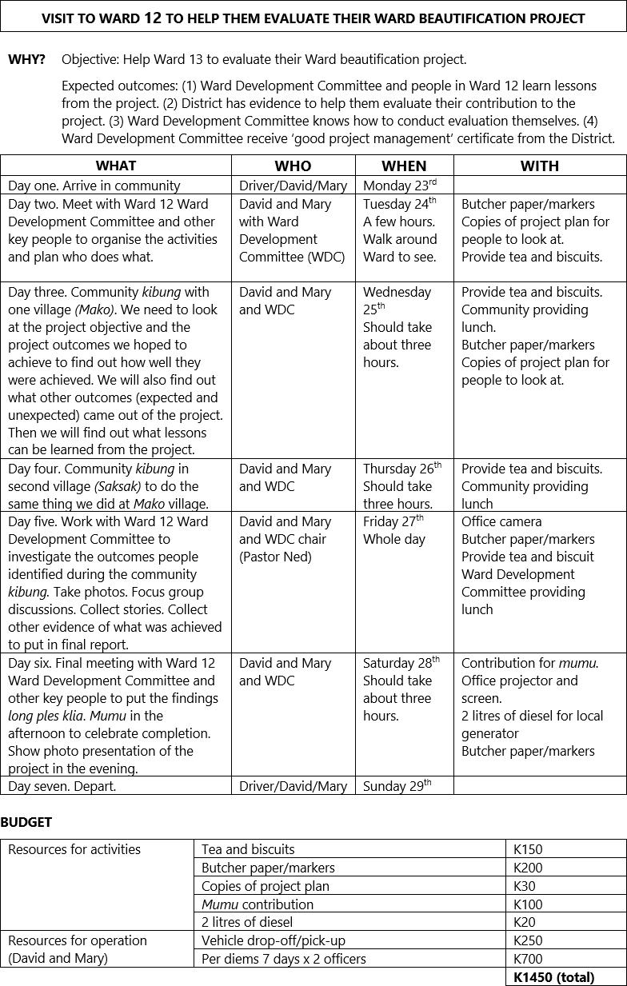

A good answer from a CDW should include at least two of the following points:

- Luk olsem the idea on day six of having a photo presentation using the office projector won’t work (because the only generator in Ward 12 is broken). They can maybe just show the photo presentation on their laptop or maski. The best thing to do is to ask the key people what they think (this is what community entry is all about).
- Having a final meeting and mumu on Saturday is probably not a good idea as most people in Ward 12 are Seventh Day Adventist. Maybe they should have the final meeting and mumu on Friday, and spread out the activities they had planned for Friday (which are more felixible) over Friday, Saturday, and Sunday. This means leaving Ward 12 a day later (on Monday. Or they could keep the same plan, but have the final meeting and mumu on Sunday afternoon. The best thing to do is to ask the key people what they think (this is what community entry is all about).
- Ask key people from Saksak village if it is still okay to proceed with activities given that one of their leaders is very sick. If it is not okay, then a solution might be to proceed but with only some key people from Saksak village (instead of everyone) so as to reduce disruption to community life. The best thing to do is to ask the key people what they think (this is what community entry is all about).

5 | Written answer  P  If you work for an organisation, then with your colleagues, list all the workplace health and safety policies and practices that you need to follow while you are in the field (during a visit). Next, list any other workplace policies that you need to follow while you are in the field (during a visit). Use this information to guide you next time you are in the field (during a visit). Don’t forget to put a copy of what you come up with in your exercise book.

A good answer from a CDW will list all of their most important field-based health and safety policies and practices (as the course facilitator you may need to check up on what the CDWs field-based health and safety policies and practices are). If the CDW doesn’t work for an organisation, then they don’t need to answer the first part of this “written answer” question (unless they are freelance and they have their own policies). The CDW also needs to list any other workplace policies they need to follow when they are in the field (during a visit) (in the office or at home). A good answer from a CDW will probably include some of the following things that they can do themselves to stay safe and healthy when they are in the field:

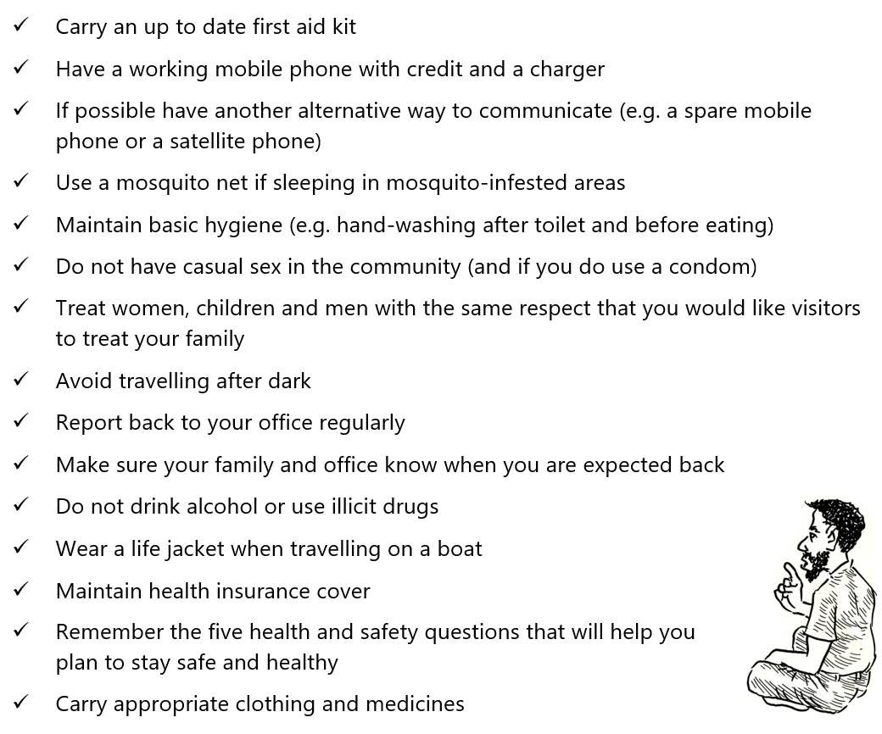

3 | Written answer  Q  Imagine that you and your colleagues have been asked by a senior officer to come up with guidelines for Community Development Workers so they know how to maintain a record of activities and movements while in the field. With your colleagues, come up with guidelines that could become your organisation’s workplace practice. When you have finished, write your answer in your exercise book.

A good answer from a CDW should include some of the following guidelines:

- Prepare your diary entry at the end of each day while in the field. In your diary entry, include things like: The activities you carried out and how well they went. The results or effects of what you did (the outcomes). Your analysis of outcomes. Who the people you met where and how many people you met. What was discussed and any decisions made. Where and when you did things. Contact details of people you may need to contact again. Notes to guide yourself about things you might need to find out more about, or follow-up on, or do differently next time. Lessons learned.

5 | Written answer  R  With your colleagues, have a look again at the example of a monitoring report at the end of the coursebook (Kwila Community Water Supply Project). Have a look again at the section with the heading report what was done during the visit, including relevant measurable information, comments, stories, and observations. What are three examples of relevant measurable information that is reported? What is one comment that is reported? What is one observation that is reported? When you have finished, write your answer in your exercise book.

A good answer from a CDW should include three of the following examples of measureable information that are included in the report:

- Dates (how many days the visit lasted can be measured). How many people were at the whole community meeting (70 people). Which key people they met with in the afternoon (numbers of key people). How long meetings went for (timing is measurable). Who they did the semi-structured interviews with (numbers of people). Who they did the focus group discussion with (numbers of people). Where they went on the village walk (numbers of places). How many people attended the final whole community meeting (80 people).
- One comment that is reported is: (Chief Karatus made the following remark at the end of the meeting) “Hau yupela halivim mipela mipela laikim stret. Ino olsem yu kam wokim nogat yu kam sapot tasol – em mipela yet husat igo pas na wokim”

2 | Written answer  S  Hopefully, you are starting to see how it all fits together. Think about what your expected outcomes will be when you make preparations, then collect information and evidence during the visit so you know if you are on track to achieve the expected outcomes, then when you prepare your report you need to report clearly whether the expected outcomes were achieved (and provide the information and evidence that proves or justifies what you say). Below are some examples of how it all fits together. With your colleagues, write down one of the examples below, but replace the first sentence with your own example (if possible, from your own experience). At the end don’t forget to put the example that you come up with in your exercise book.  Examples:  - When we made preparations to help facilitate an agreement, an expected outcome we hoped would come out of the visit was ‘the community participated effectively’. During the visit, we collected information and evidence to know if we were on track to achieve the expected outcome. Then when we prepared our report, we reported clearly whether the expected outcome was achieved (and provided the information and evidence that proved or justified what said).  - When we made preparations to help a family business to glasim na skelim sindaun (community mapping and needs analysis), an expected outcome we hoped would come out of the visit was ‘the family successfully identified and ranked their needs’. During the visit, we collected information and evidence to know if we were on track to achieve the expected outcome. Then when we prepared our report, we reported clearly whether the expected outcome was achieved (and provided the information and evidence that proved or justified what said).  - When we made preparations to help a group to monitor their water supply, an expected outcome we hoped would come out of the visit was ‘the group successfully identified whether progress was on target and whether the indicators had been achieved’. During the visit, we collected information and evidence to know if we were on track to achieve the expected outcome. Then when we prepared our report, we reported clearly whether the expected outcome was achieved (and provided the information and evidence that proved or justified what said).

A good answer from a CDW should replace the first sentence in one of the three examples above with their own example. For example: When we made preparations to run training on how to cook with kaukau, an expected outcome we hoped would come out of the visit was ‘at least half the participants were women’. During the visit, we collected information and evidence to know if we were on track to achieve the expected outcome. Then when we prepared our report we reported clearly whether the expected outcome was achieved (and provided the information and evidence that proved or justified what said).

3 | Written answer  T  Have a look again at the example of a monitoring report at the end of the coursebook (Kwila Community Water Supply Project). Have a look at the section with the heading ‘Report outcomes clearly – provide an analysis of outcomes’. Which unexpected outcomes are reported? Don’t forget to write your answer in your exercise book.

A good answer from a CDW should include at least one of the following examples of unexpected outcomes that are included in the report:

- Extending the water supply to Rupum hamlet. Also, the District Government are impressed with the project and expressed interest in building VIP toilets and standpipes at the Primary school.

2 | Written answer  U  When you provide an analysis of outcomes, you need to make it clear why an outcome happened and what it means. When you think about what it means, it helps to think about three things:  Jenny is a Community Development Worker. In her report, Jenny said an outcome was that ‘not many women participated in the awareness on how to prevent the spread of Covid 19’. Jenny reported that this happened because the tok save did not go out that women needed to attend, and also in the community men take the lead and women stay in the background. With your colleagues, discuss what this outcome means. Think about the three things above: Do you think this outcome means anything for the work (the cake)? Do you think this outcome means anything for the development lessons that luk olsem Jenny wanted the community to learn (the icing on the cake)? Do you think this outcome means anything for how Jenny worked with the community (process, policy, performance, pasin)? You weren’t there. You don’t know. Traim tasol. When you have finished, don’t forget to write your answer in your exercise book.  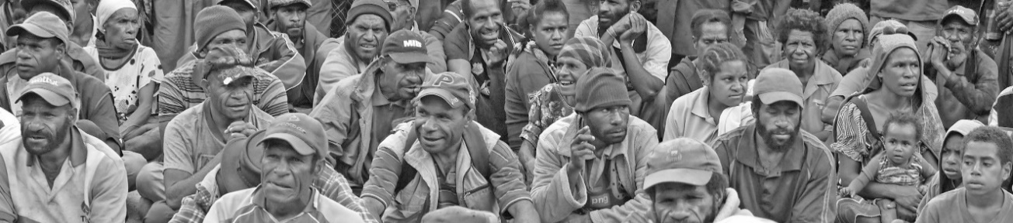
  What the outcomes mean for the WORK you are doing (the cake)?
  What the outcome means for the DEVELOPMENT LESSONS you hoped the community or group or family would learn (the icing on the cake)?
  What the outcome means for HOW you (and your organisation) work with them (process, policy, performance, pasin)?

A good answer from a CDW will include some of the following ideas (but other answers are fine if they show that the CDW can think about what outcomes mean):

- What the outcome means (for the work) is that the awareness will not be as successful because women are vital for helping to put the awareness into practice in the family. What the outcome means (for the development lessons) is that women are missing out (again) on the knowledge and pride that comes from participating and making decisions alongside men – and men miss out on seeing that decisions and actions done by men and women together are better for everyone. What the outcome means (for how we work with them) is that we need to improve how we work with key people during community entry so that the reasons for men and women participating are clear (and so that the tok save goes out in time).

2 | Written answer  V  Below are extracts from two reports. Each extract reports an outcome and then gives an analysis of the outcome. With your colleagues, come up with recommendations you would make based upon the analysis of each outcome. Don’t forget to write your answer in your exercise book.  Report One: Cholera Awareness in Aiyu  Outcome: One outcome of the Cholera Awareness with Aiyu Community was that most of the men who participated were able to identify the ways to protect themselves from cholera, but the majority of the women could not.  Analysis: Most of the awareness was conducted in tok pisin using a loud hailer. There were many men and women present, but the women sat further away than the men. I later found out that while most of the men could speak tok pisin, very few of the women could. After giving the information about cholera over the loud hailer, the audience was asked to break into family groups so that I could work with them to go through the information I had just presented. Unfortunately, this was in the late afternoon and most women had to start preparing meals. The family groups I worked with were usually made up of male family members who said that they would pass on the information to their wives, sisters and daughters.  Report Two: Monitoring a water and sanitation project in Malmal  Outcome: VIP toilets have been built by only half of the households in the project area (i.e. 31 of 65 households) but the planned completion date is due very soon.  Analysis: Although this project is reaching the planned completion date, more than half of the households have not yet built their VIP toilets. It takes at least four days for the cement to set in the slab mould (pattern) and a couple of days to build the toilet. This means it takes almost a week for the local construction team to help each household to build their VIP toilet. This has meant that it has taken eight months (rather than the expected four months) for people to build the 31 VIP toilets completed so far.

A good answer from a CDW will be similar to the following examples:

- (Report One: Cholera Awareness in Aiyu) Examples of recommendations that could be made (based on the analysis) are: Cholera awareness should be repeated in Aiyu, specifically targeting women. It should identify local women fluent in tok pisin to translate. It should be timed so that women can more easily take part in discussions and group work. The awareness activities and materials should be more suitable, and sensitive to culture and gender (we should put into practice the National Standard for awareness). Preparations and community entry should be done better, to make sure activities and materials are suitable (we should put into practice the National Standard for making preparations and conducting community entry).
- (Report Two: Monitoring a water and sanitation project in Malmal) Examples of recommendations that could be made (based on the analysis) are: Either the time frame for completion of the project could be extended, or the community should be provided with more slab moulds to complete the remaining VIP toilets more quickly. We should have done monitoring earlier to pick up this issue earlier. We need to look at how we developed the project plan with the community – maybe we could have identified this issue at the start.

Written answer
W
Congratulations. You have finished coursebook 1. Time to evaluate coursebook 1. This is not a test. The purpose of these questions is for you (and your organisation and the course facilitator) to evaluate the learning experience that you have been through. With your colleagues, answer the questions below. Don’t forget to write your answers in your exercise book.

  - Which wok mak from Element 1 (Make preparations) or Element 2 (Conduct community entry) or Element 4 (Prepare a report) are you most confused about? What are you confused about?
  - What topic in the coursebook did you find the most useful? Why?
  - What change do you recommend to improve the course or the coursebook?
  - What advice can you give to the course facilitator to help them learn lessons?
  - What more support do you need from your organisation (or the course facilitator) to help you put what you have learned into practice?
  - Any other comments?
  - Use the rating scale below to rate overall how well you understand how to make preparations (Element 1) in a way that meets the National Standard? Decide which face lines up with how you feel, then look at the letter above that face (A, B, C, D, or E), and write that letter as your answer.
  - Use the rating scale below to rate overall how well you understand how to conduct community entry and organising activities (Element 2) in a way that meets the National Standard? Decide which face lines up with how you feel, then look at the letter above that face (A, B, C, D, or E), and write that letter as your answer.
  - Use the rating scale below to rate overall how well you understand how to prepare a report (Element 4) in a way that meets the National Standard? Decide which face lines up with how you feel, then look at the letter above that face (A, B, C, D, or E), and write that letter as your answer.

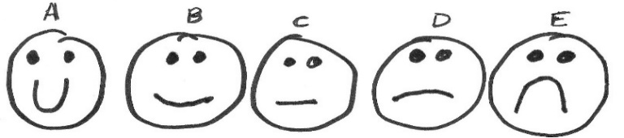

Finally, look at the answers the CDW has written for the evaluation questions. There is no right or wrong answer (as long as they have made an effort to answer the questions). You (the course facilitator) need to take note of what they have written because it will help you improve how you facilitate the course. If you need to write a report for your organisation, then you can use this evaluation information to help you. If you can, also get in touch with the PNG CDW Industry Technical Committee (ITC) through the ‘contact us’ link at pngcdwstandard.com and say that you want to send them the evaluation information. The PNG CDW ITC will get in touch with you by email and then you can email the evaluation information (or your report) to them. Doing this helps the PNG CDW ITC to improve the course and the coursebooks.

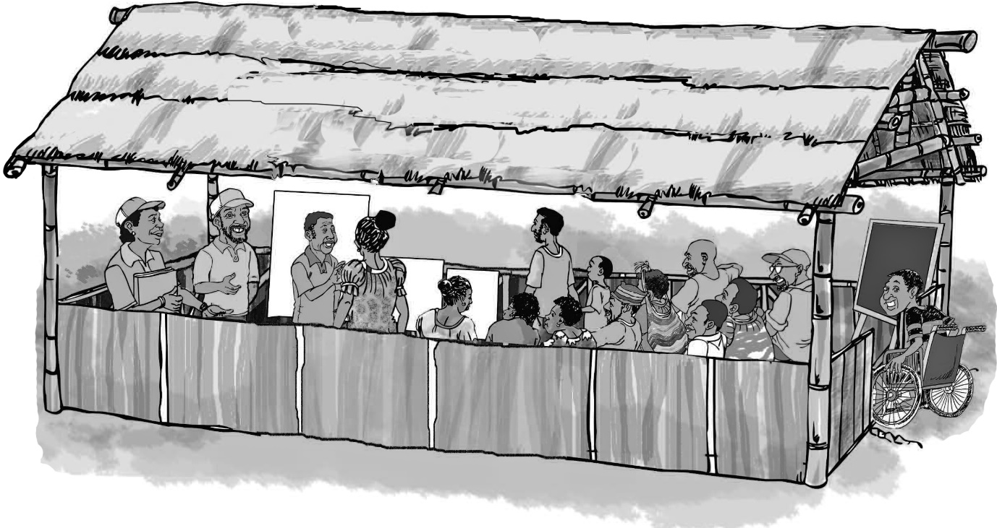
Sample written answers for CDW Coursebook 2

Below are the “written answer” questions from CDW coursebook 2. Underneath each question is an example of a good answer. Don’t forget, this is not a test. If a CDW has made a mistake or has a different answer, then it doesn’t mean they have failed. If they have tried their best to answer every question, then fine. But you definitely need to give feedback to the CDW, so they learn from their mistakes. The best way to do this is to meet with them and go through their answers one by one. If you can’t meet with them, then give them feedback on the phone or online.

3 | Written answer  A  With your colleagues, write the coursebook objective on a poster na putim long ples klia. Leave it long ples klia until you complete this coursebook. For coursebook 2 (this coursebook) the objective is to Understand how to conduct training and awareness in a way that meets the Standard. Next, in your exercise book, write the coursebook objective in big letters.

A good answer from a CDW is:

- Understand how to conduct training and awareness in a way that meets the Standard

1 | Written answer  B  With your colleagues, look at the four Elements that make up Unit C01 Conduct Community Awareness (on page 12). What are the two Elements that you should have already put into practice before beginning the awareness (or the training)? Next, in your exercise book, write down your answer.

A good answer from a CDW is:

- Element 1 Make Preparations and Element 2 Conduct Community Entry

3 | Written answer  C  With your colleagues, discuss different ways to encourage and support effective participation and inclusion. Next, in your exercise book, write down five things you plan to do to support and encourage women and youth to get involved and contribute their ideas next time you conduct training or awareness?

A good answer from a CDW will probably include 5 of the following ways to support and encourage women and youth to get involved and contribute their ideas next time they conduct training or awareness – but other ideas are also fine:

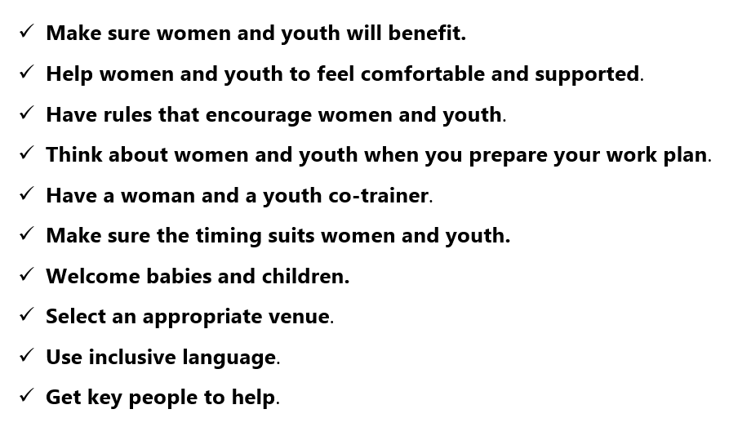

4 | Written answer  D  With your colleagues, discuss why encouraging key people to take the lead is important. Next, in your exercise book, explain four things you want to try next time you conduct awareness to encourage key people to take the lead.

A good answer from a CDW will probably include 4 of the following ideas – but other ideas are also fine:

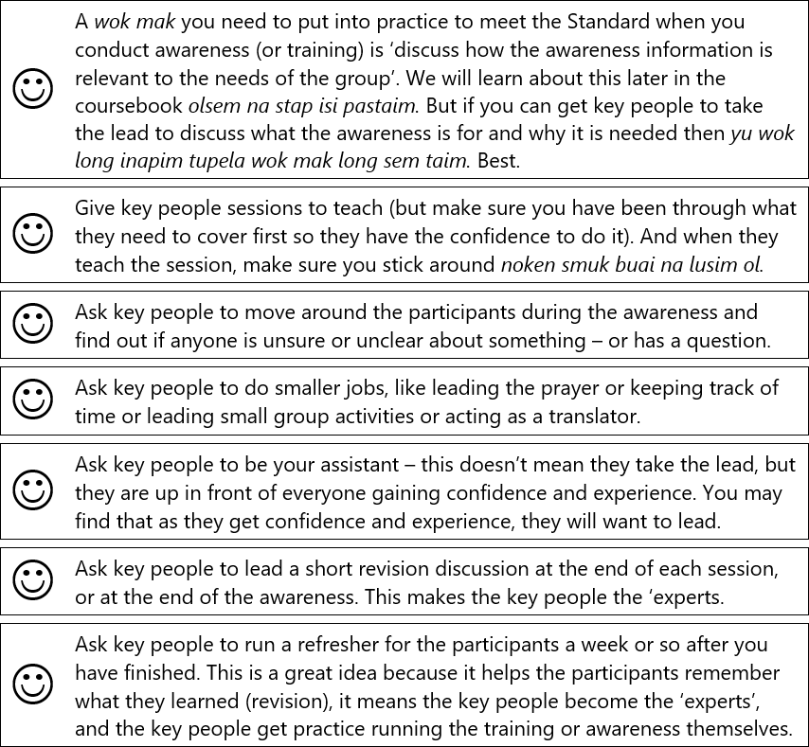

3 | Written answer  E  With your colleagues, discuss how to use two-way communication. Next, in your exercise book, write down three things you should do to use two-way communication next time you conduct training or awareness.

A good answer from a CDW will probably include 3 of the following ways to use two-way communication next time they conduct training or awareness – but other ideas are also fine:

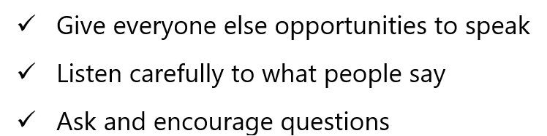

2 | Written answer  F  With your colleagues, choose a training or awareness topic that might challenge or test local culture. Discuss how the Community Development Worker could put into practice the four points (above). What should they do and say? Next, in your exercise book, write down four things you should do during community entry if the training or awareness might challenge or test local culture.

A good answer from a CDW will probably include the following 4 things – but other ideas are also fine:

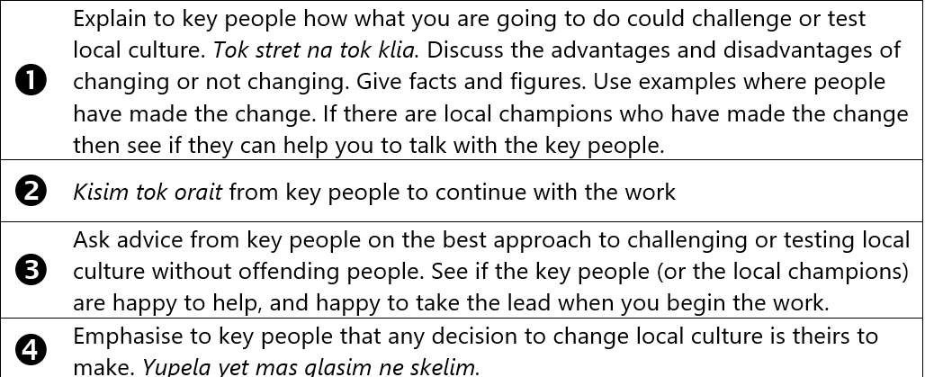

3 | Written answer  G  With your colleagues, choose one of the training or awareness topics from the list of three topics below. These topics could challenge or test local culture. Pretend that you need to conduct this topic in a community that you normally work with. The first three things you should do are the “three things to do before starting training or awareness” (above). Next, use your experience as Community Development Workers to come up with three more suggestions or pieces of advice for how you could deliver the topic in a way that is appropriate to local culture. Stia tok. Finally, in your exercise book, write down which topic you chose, and then list the “three things to do before starting training or awareness”, and then the three extra suggestions or pieces of advice you came up with.    - How to practice safe sex  - Domestic violence  - Family planning

A good answer from a CDW about how to practice safe sex will be similar to the following:

- Try and start your relationship by helping them to do glasim na skelim sindaun
- Make preparations for the visit (Element 1) in a way that meets the Standard
- Do community entry (Element 2) in a way that meets the Standard
- Talk to men and women about safe sex in separate groups
- Have a woman CDW talk to women and a man CDW talk to men
- See if key people can help you talk about safe sex, and explain why it is necessary

9 | Written answer  H  With your colleagues, go back over the 7 principles of adult learning. Point at each of the posters you have put on the wall and make sure that you are all clear about what each principle is and how to put it into practice. Next, in your exercise book, write down the seven principles of adult learning. Raitim gut.

A good answer from a CDW is below:

Learning occurs best when the learner knows what they are supposed to be learning

Learning occurs best when the learner thinks that what you want them to learn will be useful

Learning occurs best when you start with what the learner already knows

Learning occurs best when the trainer explains by SHOW and TELL

Learning occurs best when the learner has a chance to LEARN BY DOING

Learning occurs best when the learner goes back over what they have learned at the end

Learning occurs best when a learner feels comfortable and supported

10 | Written answer  I  Copy the lesson plan that you developed in the last activity into your exercise book.

A good answer from a CDW will be a good example of a lesson plan using the four-step lesson plan. The lesson plan should put into practice many or most of the seven principles of adult learning. As the course facillitator, you will need to use your judgement.

4 | Written answer  J  In the last topic we learned a four-step lesson plan that you can use to conduct training or awareness. During what steps in the four-step lesson plan can you discuss how the information is relevant to the needs of the group? Next, in your exercise book, write down your answer.  

A good answer from a CDW will be something like the following:

- You can discuss how awareness information is relevant to the needs of the group during any of the steps of a lesson plan. The more you do it the better.

5 | Written answer  K  In your exercise books, write down four reasons why it is a good idea to ask the participants themselves how or if the information will be useful.

A good answer from a CDW will probably include the following 4 things – but other ideas are also fine:

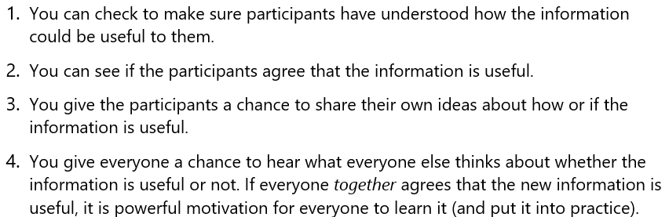

2 | Written answer  L  In your exercise book, write down the heading ‘Brainstorm’, then write down FIVE SIMPLE RULES for a brainstorm to be effective.

A good answer from a CDW is below:

Brainstorm

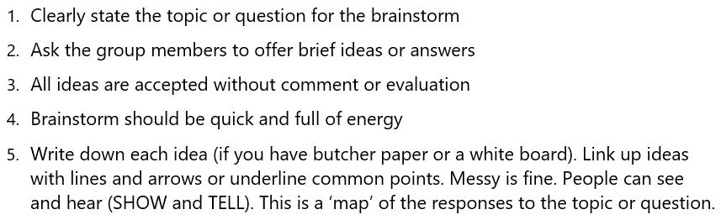

3 | Written answer  M  In your exercise book, write down the heading ‘Icebreaker’, then write down how to do one icebreaker that you want to try out next time you conduct training or awareness. Raitim gut.

A good answer from a CDW will explain how to do one suitable icebreaker.

4 | Written answer  N  In your exercise book, write down the heading ‘Energiser’, then write down how to do one energiser that you want to try out next time you conduct training or awareness. Raitim gut.

A good answer from a CDW will explain how to do one suitable energiser.

5 | Written answer  O  In your exercise book, write down the heading ‘Presentation’, then write down the four ways to make your presentation work. Raitim gut.

A good answer from a CDW will probably include the following four ways to make your presentation work – but other ideas are also fine:



6 | Written answer  P  In your exercise book, write down the advantages of small groups. Raitim gut.

A good answer from a CDW will probably include the following points – but other ideas are also fine:

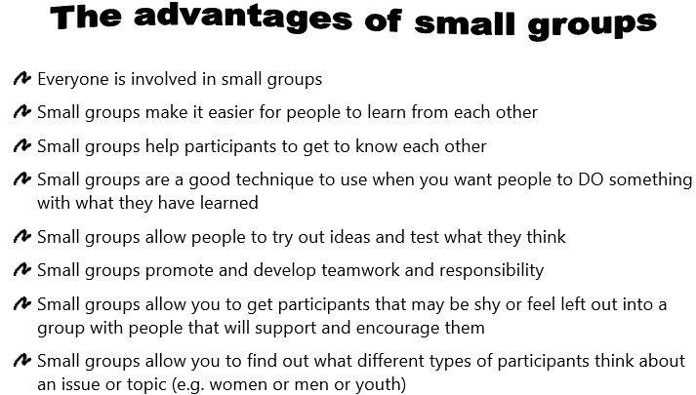

8 | Written answer  Q  In your exercise book, write down the advantages of working in pairs. Raitim gut.

A good answer from a CDW will probably include the following points – but other ideas are also fine:

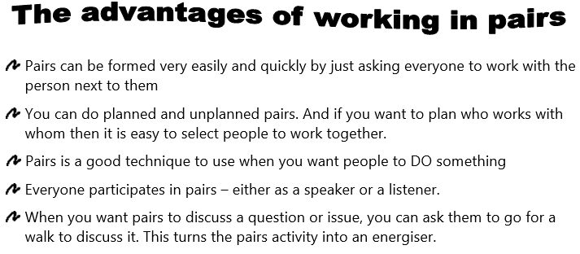

2 | Written answer  R  In your exercise book, write down three ways to find out if there is misunderstanding or confusion that you want to try next time you conduct training or awareness?

A good answer from a CDW will probably include three of the following points – but other ideas are also fine:

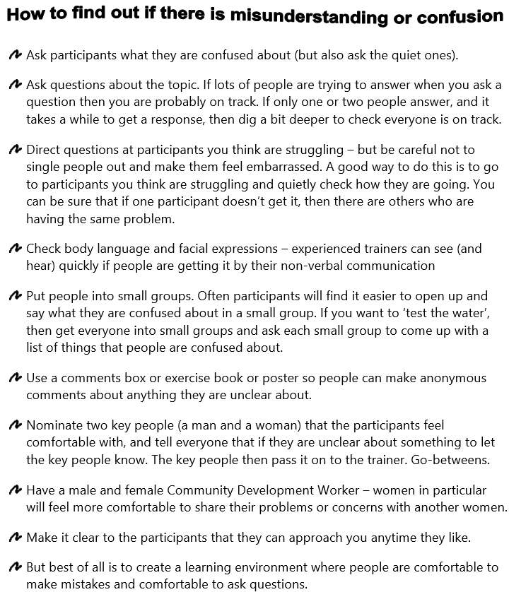

3 | Written answer  S  In your exercise book, draw the learning from experience cycle.

A good answer from a CDW is:

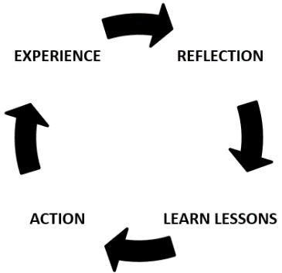

4 | Written answer  T  In your exercise book, copy down the checklist for learning lessons from training or awareness. Raitim gut.

A good answer from a CDW will be something like the following:

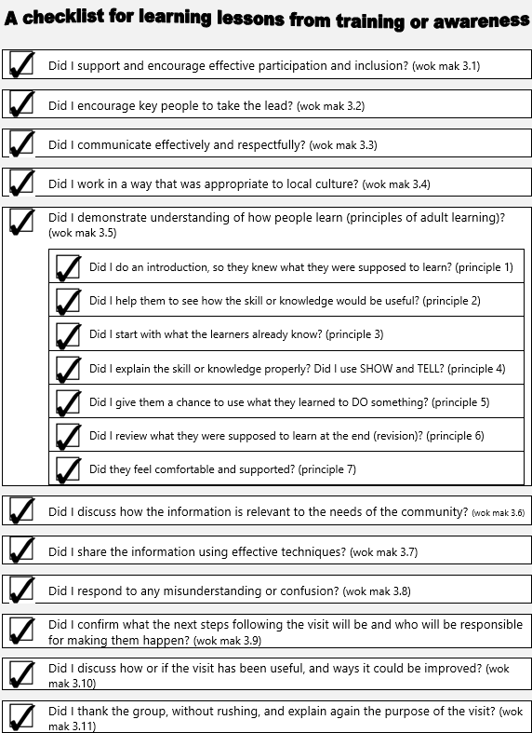

2 | Written answer  U  In your exercise book, copy down how to do an action plan. Raitim gut.

A good answer from a CDW will be something like the following:

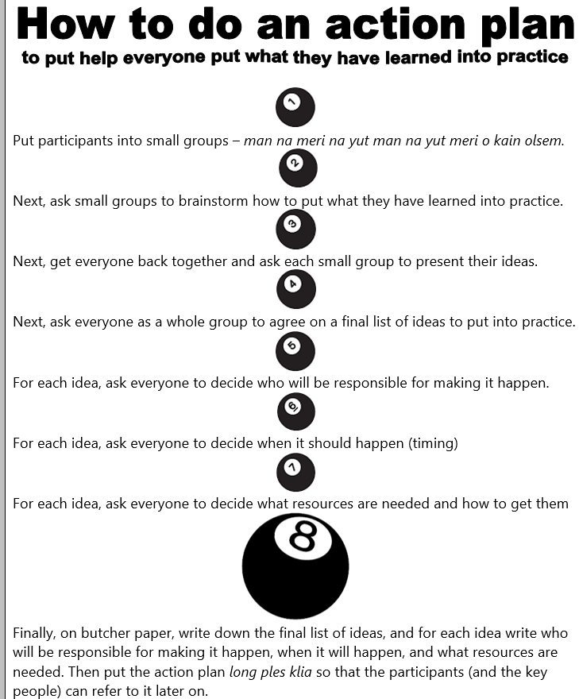

3 | Written answer  V  In your exercise book, write down five feedback questions that you think would be good to ask next time you conduct training?

A good answer from a CDW will probably include the following – but other ideas are also fine:

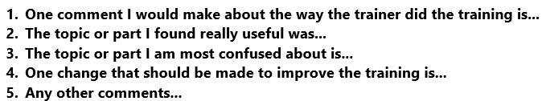

1 | Written answer  W  In your exercise book, write down the final wok mak you need to inapim if you want to conduct training or awareness in a way that meets the Standard.

A good answer from a CDW is:

- Thank the group, without rushing, and explain again the purpose of the visit.

Written answer
X
Congratulations. You have finished coursebook 2. Time to evaluate coursebook 2. This is not a test. The purpose of these questions is for you (and your organisation and the course facilitator) to evaluate the learning experience that you have been through. With your colleagues, answer the questions below. Don’t forget to write your answers in your exercise book.

  - Which wok mak from CDW Unit C01 (Conduct Community Awareness) are you most confused about? What are you confused about?
  - What topic in the coursebook did you find the most useful? Why?
  - What change do you recommend to improve the course or the coursebook?
  - What advice can you give to the course facilitator to help them learn lessons?
  - What more support do you need from your organisation (or the course facilitator) to help you put what you have learned into practice?
  - Any other comments?
  - Use the rating scale below to rate overall how well you understand how to conduct awareness (or training) in a way that meets the National Standard? Decide which face lines up with how you feel, then look at the letter above that face (A, B, C, D, or E), and write that letter as your answer.

Finally, look at the answers the CDW has written for the evaluation questions. There is no right or wrong answer (as long as they have made an effort to answer the questions). You (the course facilitator) need to take note of what they have written because it will help you improve how you facilitate the course. If you need to write a report for your organisation, then you can use this evaluation information to help you. If you can, also get in touch with the PNG CDW Industry Technical Committee (ITC) through the ‘contact us’ link at pngcdwstandard.com and say that you want to send them the evaluation information. The PNG CDW ITC will get in touch with you by email and then you can email the evaluation information (or your report) to them. Doing this helps the PNG CDW ITC to improve the course and the coursebooks.

Sample written answers for CDW Coursebook 3

Below are the “written answer” questions from CDW coursebook 3. Underneath each question is an example of a good answer. Don’t forget, this is not a test. If a CDW has made a mistake or has a different answer, then it doesn’t mean they have failed. If they have tried their best to answer every question, then fine. But you definitely need to give feedback to the CDW, so they learn from their mistakes. The best way to do this is to meet with them and go through their answers one by one. If you can’t meet with them, then give them feedback on the phone or online.

2 | Written answer  A  With your colleagues, read the pamphlet on the PNG National Standard for CDWs (at the end of this coursebook). The National Standard lists 12 jobs (Units) that CDWs often do. Six of these 12 Units line up with the six steps of a project cycle. In your exercise books, write down which six Units line up with the six steps, and circle the two Units that we are going to look at in this coursebook.

A good answer from a CDW is below:

Step 1 Assist group to analyse their development situation and identify priorities (glasim na skelim sindaun)

Step 2 Assist group to develop a project plan for a community activity (kamapim projek plen)

Step 3 Facilitate agreements for a community activity (kamapim wanbel)

Step 4 Facilitate the start-up of a community activity (set gut na statim wok)

Step 5 Monitor community activity (sekim wok)
Step 6 Evaluate community activity outcomes (lukluk bek na skelim)

2 | Written answer  B  With your colleagues, write the coursebook objective on a poster na putim long ples klia. Leave it long ples klia until you complete this coursebook. For coursebook 3 (this coursebook) the objective is Understand how to help a group to glasim na skelim sindaun (step 1 of the project cycle) and develop a project plan (step 2 of the project cycle) in a way that meets the Standard. Next, in your exercise book, write the coursebook objective in big letters.

A good answer from a CDW is:

- Understand how to help a group or community to glasim na skelim sindaun (step 1 of the project cycle) and develop a plan (step 2 of the project cycle) in a way that meets the Standard.

3 | Written answer  C  With your colleagues, discuss ways to support and encourage women, youth, and people living with a disability to participate effectively during a kibung. Next, in your exercise book, write down five things you plan to do to support and encourage women to participate effectively next time you facilitate a kibung.

A good answer from a CDW will probably include five of the following ways to include women to get involved and contribute their ideas next time they facilitate a kibung – but other ideas are also fine:

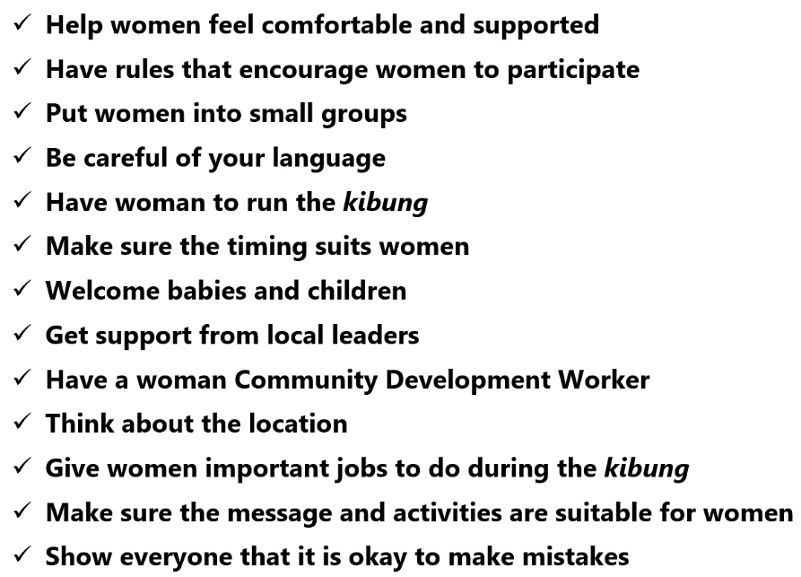

3 | Written answer  D  With your colleagues, discuss why encouraging key people to take the lead is important. Next, in your exercise book, explain four things you want to do next time you help a group or community to encourage key people to take the lead.

A good answer from a CDW will probably include 4 of the following ways to encourage key people to take the lead – but other ideas are also fine:

- Always try and make sure the key people I work with include people who want to learn why to do it and how to do it - so that eventually they will be able to do it themselves without my help
- Before I do something, sit down with key people and explain what will happen and why it is necessary. Adults learn best when they know what is going to happen.
- When I do something, encourage key people to observe me, and tell them what they need to learn. Adults learn best when they know what they are supposed to learn.
- When I do something, encourage key people to take the lead. Adults learn best when they have a chance to learn by doing.
- After I have finished, sit down with key people and go back over what we did together. Adults learn best when they have a chance to go back over what they learned. Revision.
- If possible, help key people who have the potential to be Community Development Workers to learn the wok mak from the National Standard. And if possible, help them get assessed and accredited.

4 | Written answer  E  With your colleagues, discuss how to communicate effectively and respectfully. Next, in your exercise book, explain three things you plan to do next time you work in a community to try and communicate effectively.

A good answer from a CDW will probably include three of the following things you can do to try and communicate effectively, but other answers are fine:

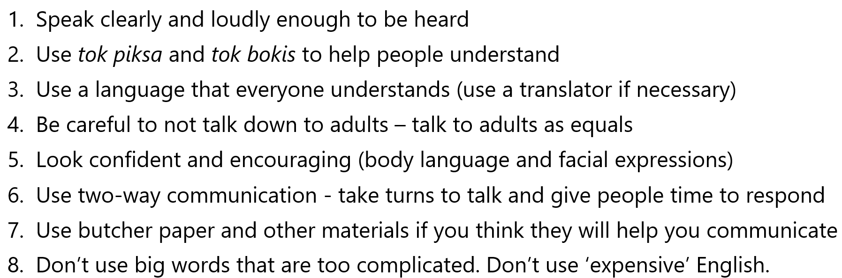

3 | Written answer  F  With your colleagues, discuss what a Community Development Worker should do to work in a way that is appropriate to local culture. Next, in your exercise book, explain three things you plan to do next time you work in a community so that you work in a way that is appropriate to local culture.

A good answer from a CDW will probably include three of the following things you can do to work in a way that is appropriate to local culture, but other answers are fine:

- Make sure you conduct community entry properly (in a way that meets the Standard)
- Respect local customs
- When you start the work you came to do, respect local culture (especially if the work you are doing will challenge local kastom).
- When you exit the community after finishing the work, take your time and do it properly. Don’t rush. Respect local kastom. Pasin.
- Put yourself in their shoes, and think about how they will see you. Yu husat?

4 | Written answer  G  When you start the kibung to help the group glasim na skelim sindaun (step 1 of the project cycle), you need to explain the purpose of the visit and why it is important that everyone from the group participates to analyse their development situation and identify priorities. Discuss with your colleagues how you would put this wok mak into practice. Next, in your exercise book, write down two dot points to guide you when you do it.

A good answer from a CDW will be something like the following:

- Explain all the six steps of a project cycle together in a way that everyone will understand (like using the example of a family)
- Explain how encouraging participation of everyone (not just leaders and key people) makes the work more successful, supports inclusive development, and grows goodwill.

9 | Written answer  H  With your colleagues, go back over what Merilyn did to help everyone analyse Mama Kirap’s first mission? Discuss how to do a ples map, how to use the five questions to kirapim toktok, and how to stiaim toktok. Next, in your exercise book, list the five questions to kirapim toktok, and the three things to stiaim toktok.

A good answer from a CDW is below:

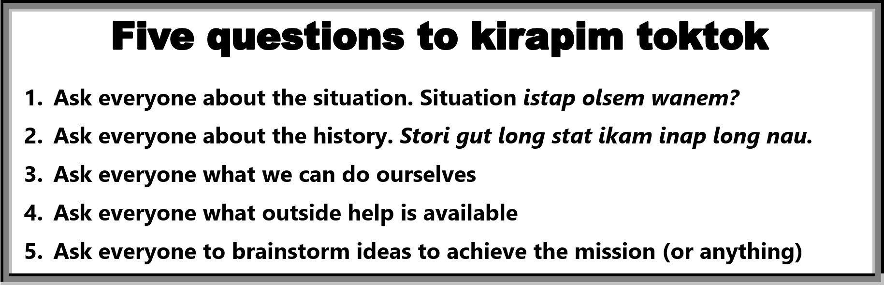



5 | Written answer  I  Discuss what development really means with your colleagues. Next, in your exercise book, explain what development really means.

A good answer from a CDW is something like the following:

- Development is about helping people. Development is not about things.

5 | Written answer  J  Imagine you are working with a family, and they say their priority need or idea is ‘bigger coffee garden’. With your colleagues, discuss how you would re-write this priority need or idea so that it is a ‘people-centered’? When you have finished, write down your answer in your exercise book.

A good answer from a CDW is something like the following:

- Our family doesn’t have enough money for our needs

7 | Written answer  K  In your exercise book, copy the causes and effects map, the strengths and weaknesses, and the opportunities and challenges that Hasarai came up with for their problem ‘teenagers are being damaged by drug abuse’.

A good answer from a CDW is below:

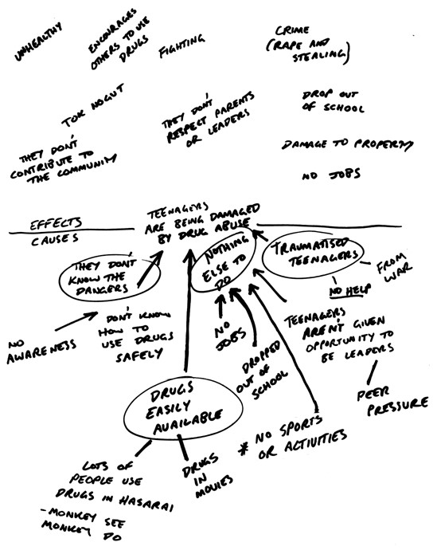

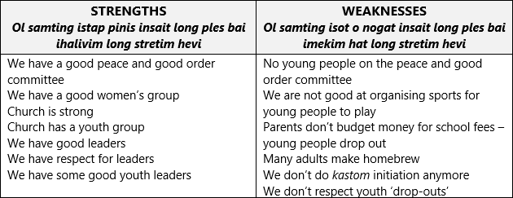
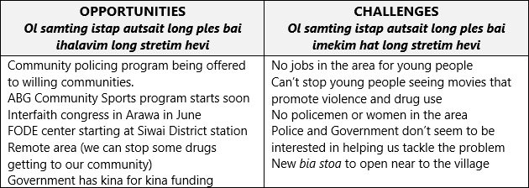

1 | Written answer  L  With your colleagues, discuss the final three wok mak that you need to put into practice when you help a group to do glasim na skelim sindaun. Next, in your exercise book, briefly explain each of the final three wok mak.

A good answer from a CDW is something like the following:

- Discuss what the next steps following the visit will be and who will be responsible for making them happen. It is always important to agree on what the next steps are, and who will be responsible for making them happen, before you finish glasim na skelim sindaun.
- Discuss how or if the visit has been useful, and ways it could be improved. It is always important to find out if the work you did to help the group was useful so you can improve as a CDW.
- Thank the group, without rushing, and explain again the purpose of the visit. It is always important to leave the community in the right way. Some Community Development Workers call this ‘community exit’. Take your time. Do it properly. Show respect. Remind everyone of what glasim na skelim sindaun was for.

1 | Written answer  M  With your colleagues, look again at topics 3.1, 3.2, 3.3, and 3.4 from Unit C07 Element 3 (the first four topics in this coursebook). Briefly go through each topic again to refresh yourselves. Kirapim bek tinging. Next, in your exercise book, write the heading ‘Unit C05 Assist group to develop a project plan for a community activity’, and then underneath write the first four wok mak that you need to inapim (below).  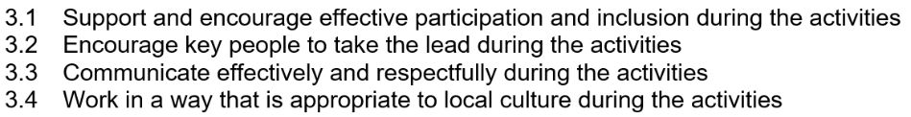

The CDW should have written the heading ‘Unit C05 Assist group to develop a project plan for a community activity’, and then underneath they should have written the following four performance criteria:

3.1 Support and encourage effective participation and inclusion during the activities

3.2 Encourage key people to take the lead during the activities

3.3 Communicate effectively and respectfully during the activities

3.4 Work in a way that is appropriate to local culture during the activities

4 | Written answer  N  With your colleagues, discuss why it is a good idea to review what happened in step 1 of the project cycle first before explaining this step of the project cycle (step 2 kamapim plen). Next, in your exercise book, write your answer.

A good answer from a CDW is something like the following:

- It is a good idea to review glasim na skelim sindaun (step 1) first so that the people you are working with are reminded of the story so far. If the group or community is going to have ownership of the project, you need to take every opportunity to remind everyone that it is their project and it was their idea. Yupela yet papa bilong toktok. Yupela yet ibin glasim na skelim sindaun. Yupela yet wanbel long wokim plen.

5 | Written answer  O  In your exercise book, draw the two solution trees shown above. Next, explain how a good project plan is like a healthy fruit tree. Mekim gut.

A good answer from a CDW is something like the following:

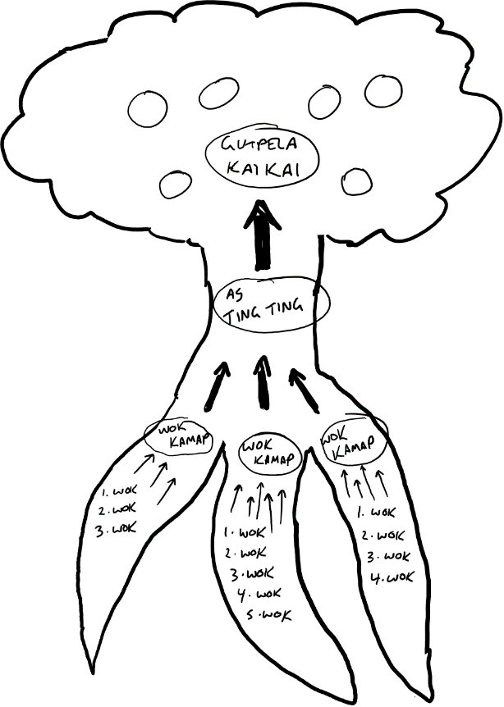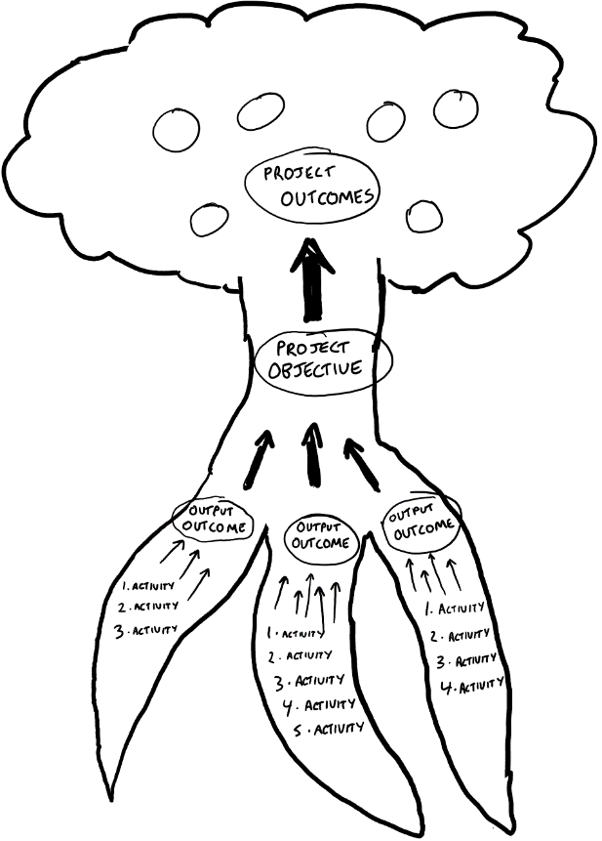

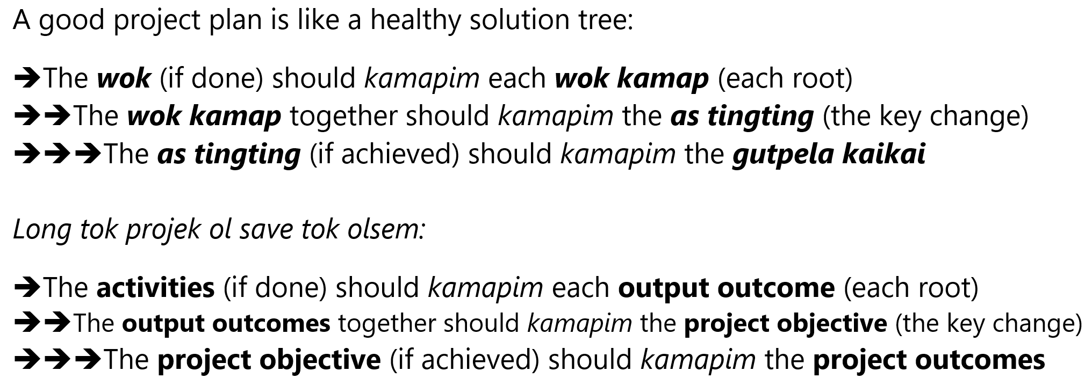

7 | Written answer  P  With your colleagues, go back over what Merilyn did to help the key people work out the bones of their project plan. She began by turning the causes and effects map into a problem tree. Then she helped them turn the problem tree into a solution tree. Then she helped them turn the solution tree into a project tree. Tingim. In your exercise book, briefly explain what Merilyn did.

A good answer from a CDW is something like the following:

- Merilyn began by turning the causes and effects map into a problem tree. Then she helped them turn the problem tree into a solution tree. Then she helped them turn the solution tree into a project tree.

2 | Written answer  Q  With your colleagues, discuss what you need to put in the ‘sustainability’ section of a project plan. Next, in your exercise book, explain the two questions to ask to help sustain the impact of each output outcome (each root of the solution).

A good answer from a CDW is something like the following:

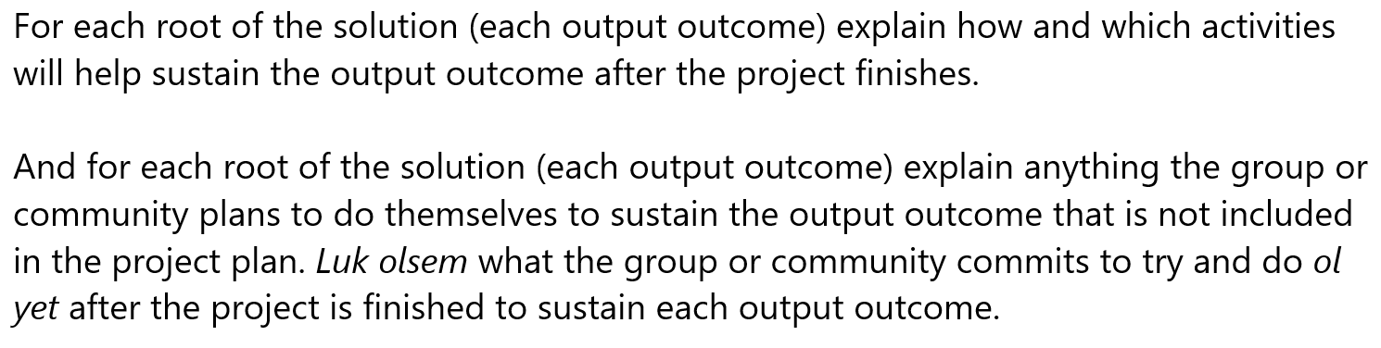

3 | Written answer  R  With your colleagues, discuss what you need to put in the ‘risk management’ section of a project plan. Next, in your exercise book, explain how to do a risk management table for each output outcome (each root of the solution).

A good answer from a CDW is something like the following:

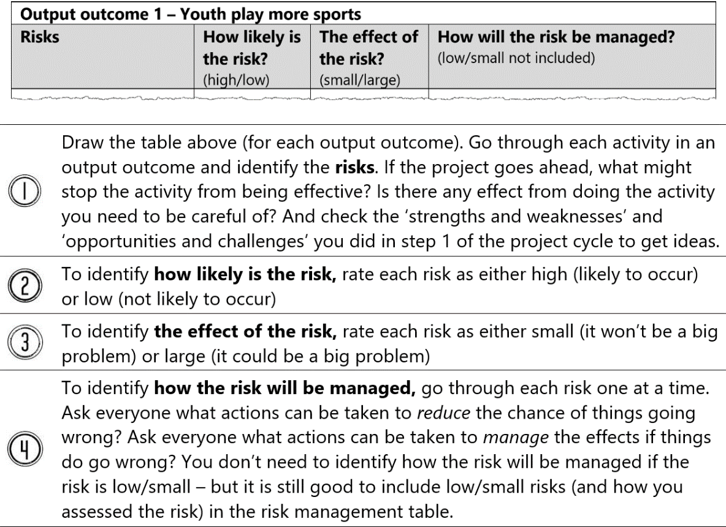

2 | Written answer  S  With your colleagues, discuss how to do an activity schedule table. Next, in your exercise book, copy the activity schedule for output outcome 1 from the Hasarai project plan. Just show activity 1.1.1 and 1.1.2 em inap.

A good answer from a CDW is something like the following:

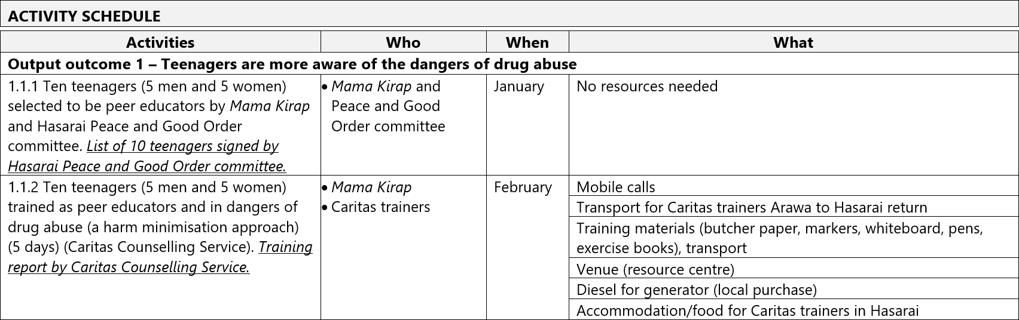

4 | Written answer  T  With your colleagues, discuss how to make a budget table. Next, in your exercise book, write down the eight steps to develop a project budget.

A good answer from a CDW is something like the following:

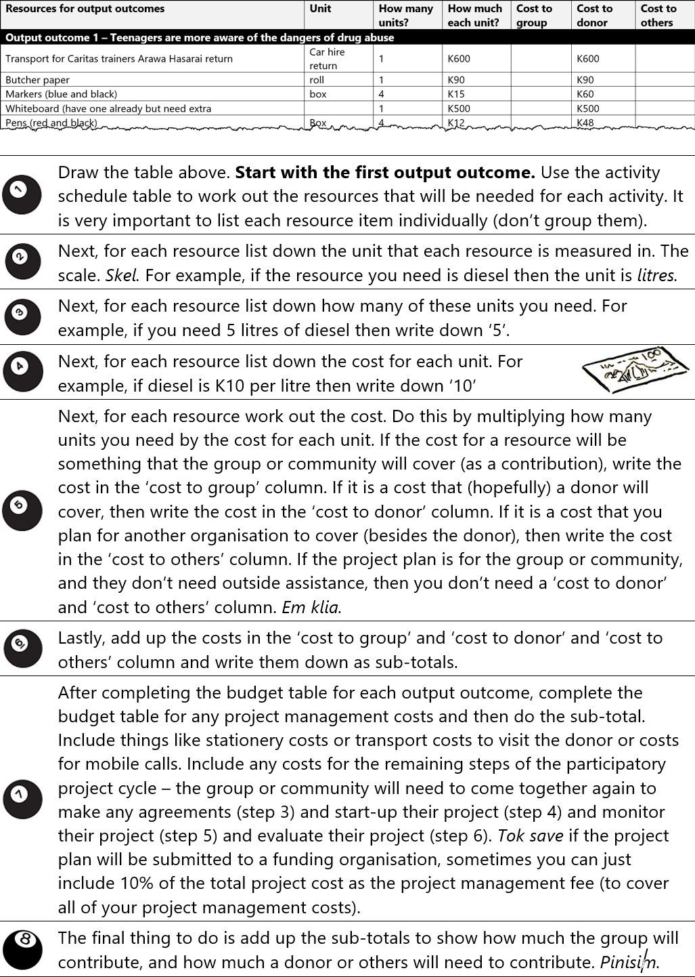

2 | Written answer  U  With your colleagues, discuss how to work with the group to review and confirm the plan. Next, in your exercise book, explain why it is important that everyone in the group gets a chance to review and confirm the plan.

A good answer from a CDW is something like the following:

- It is very important that the whole group or community get to see the project plan because it is their plan. They need to understand it. Nogut ol stat long tok olsem emi plen bilong ol ki pipol. Nogut ol stat long tok olsem ino samting bilong mipela.

3 | Written answer  V  With your colleagues, discuss the final three wok mak that you need to put into practice when you help a group to develop a project plan. Next, in your exercise book, write down the final three wok mak that you need to inapim.

A good answer from a CDW is:

- Discuss what the next steps following the visit will be and who will be responsible for making them happen
- Discuss how or if the visit has been useful, and ways it could be improved
- Thank the group, without rushing, and explain again the purpose of the visit

Written answer
W
Congratulations. You have finished CDW Coursebook 3. Time to evaluate CDW Coursebook 3. This is not a test. The purpose of these questions is for you (and your organisation and the course facilitator) to evaluate the learning experience that you have been through. With your colleagues, answer the questions below. Don’t forget to write your answers in your exercise book.

  - Which wok mak from CDW Unit C07 Element 3 (Assist group to analyse their development situation and identify priorities) or CDW Unit C05 Element 3 (Assist group to develop the project plan) are you most confused about? What is confusing?
  - What topic in the coursebook did you find the most useful? Why?
  - What change do you recommend to improve the course or the coursebook?
  - What advice can you give to the course facilitator to help them learn lessons?
  - What more support do you need from your organisation (or the course facilitator) to help you put what you have learned into practice?
  - Any other comments?
  - Use the rating scale below to rate overall how well you understand how to conduct community mapping and needs analysis in a way that meets the National Standard? Decide which face lines up with how you feel, then look at the letter above that face (A, B, C, D, or E), and write that letter as your answer.
  - Use the rating scale below to rate overall how well you understand how to develop a plan in a way that meets the National Standard? Decide which face lines up with how you feel, then look at the letter above that face (A, B, C, D, or E), and write that letter as your answer.

Finally, look at the answers the CDW has written for the evaluation questions. There is no right or wrong answer (as long as they have made an effort to answer the questions). You (the course facilitator) need to take note of what they have written because it will help you improve how you facilitate the course. If you need to write a report for your organisation, then you can use this evaluation information to help you. If you can, also get in touch with the PNG CDW Industry Technical Committee (ITC) through the ‘contact us’ link at pngcdwstandard.com and say that you want to send them the evaluation information. The PNG CDW ITC will get in touch with you by email and then you can email the evaluation information (or your report) to them. Doing this helps the PNG CDW ITC to improve the course and the coursebooks.

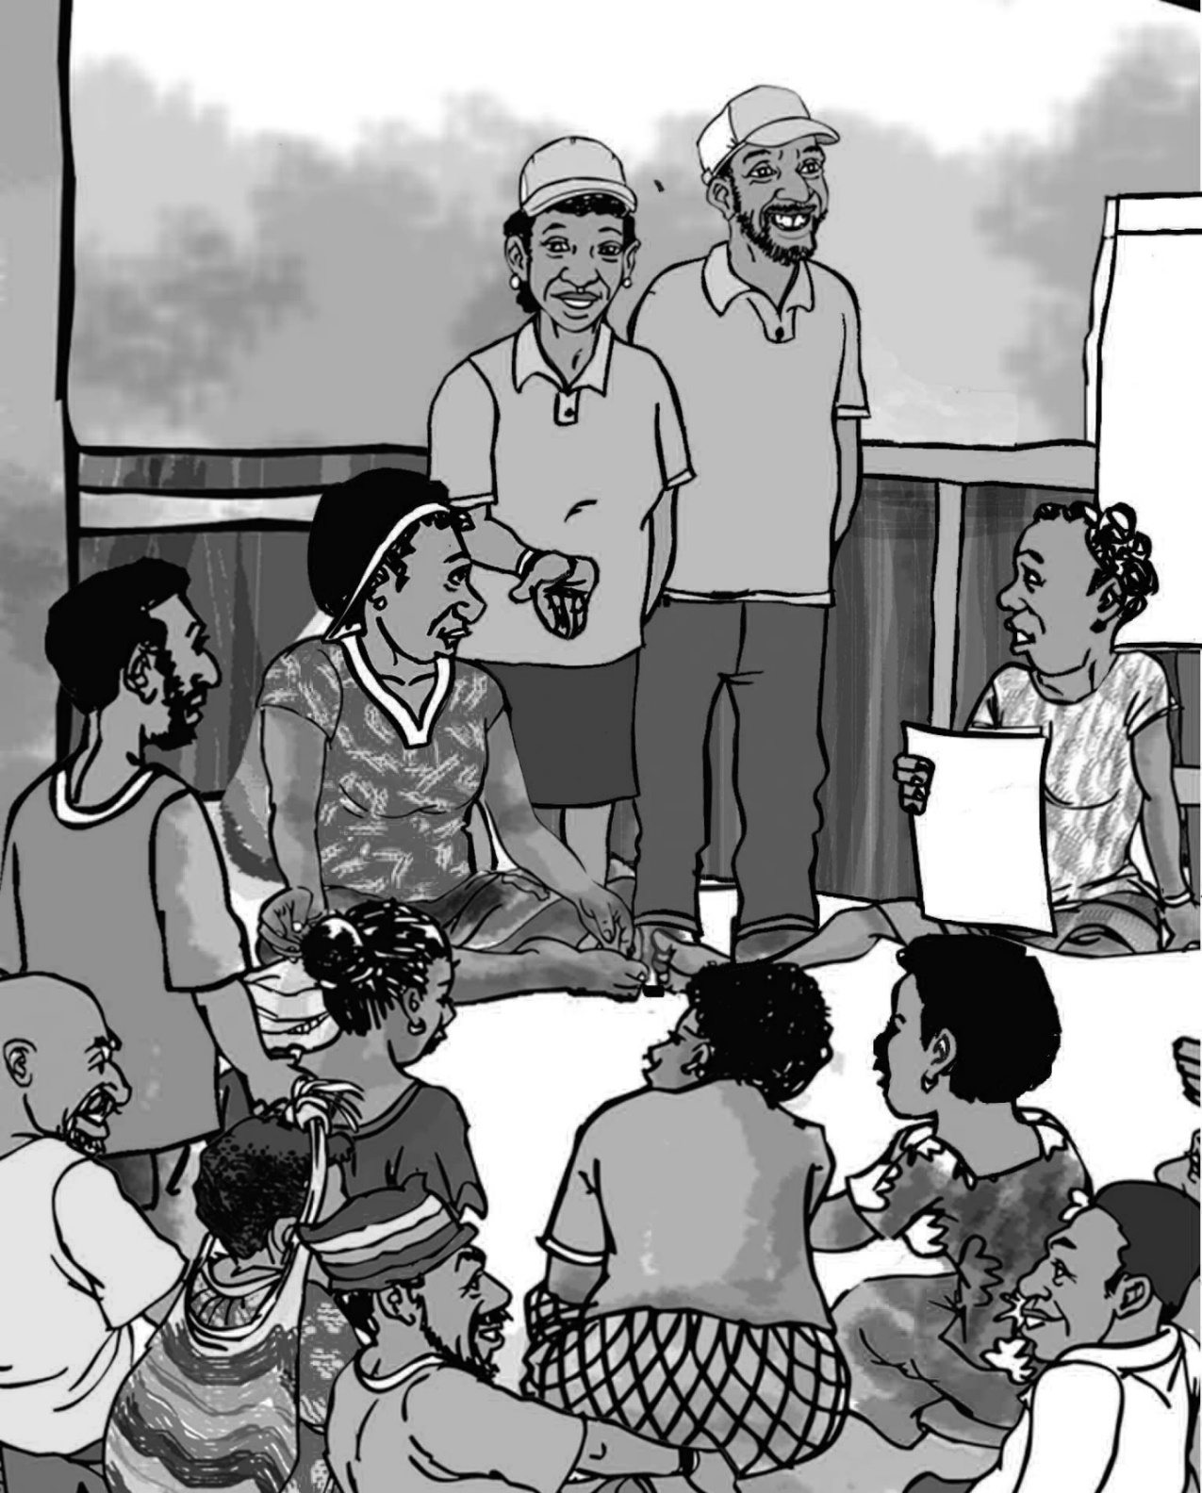
Sample written answers for CDW Coursebook 4

Below are the “written answer” questions from CDW coursebook 4. Underneath each question is an example of a good answer. Don’t forget, this is not a test. If a CDW has made a mistake or has a different answer, then it doesn’t mean they have failed. If they have tried their best to answer every question, then fine. But you definitely need to give feedback to the CDW, so they learn from their mistakes. The best way to do this is to meet with them and go through their answers one by one. If you can’t meet with them, then give them feedback on the phone or online.

2 | Written answer  A  With your colleagues, read the pamphlet on the PNG National Standard for CDWs (at the end of this coursebook). The National Standard lists 12 jobs (Units) that CDWs often do. Six of these 12 Units line up with the six steps of a project cycle. In your exercise books, write down which six Units line up with the six steps, and circle the two Units that we are going to look at in this coursebook.

A good answer from a CDW is below:

Step 1 Assist group to analyse their development situation and identify priorities (glasim na skelim sindaun)

Step 2 Assist group to develop a project plan for a community activity (kamapim projek plen)

Step 3 Facilitate agreements for a community activity (kamapim wanbel)

Step 4 Facilitate the start-up of a community activity (set gut na statim wok)

Step 5 Monitor community activity (sekim wok)
Step 6 Evaluate community activity outcomes (lukluk bek na skelim)

2 | Written answer  B  With your colleagues, write the coursebook objective on a poster na putim long ples klia. Leave it long ples klia until you complete this coursebook. For CDW Coursebook 4 (this coursebook) the objective is Understand how to facilitate agreements for a community activity (step 3 of the project cycle) and facilitate the start-up of a community activity (step 4 of the project cycle) in a way that meets the Standard. Next, in your exercise book, write the coursebook objective in big letters.

A good answer from a CDW is:

- Understand how to help a group or community to facilitate agreements for a project (step 3 of the project cycle) and facilitate the start-up of the project (step 4 of the project cycle) in a way that meets the Standard.

3 | Written answer  C  With your colleagues, discuss ways to support and encourage women, youth, and people living with a disability to participate effectively during a kibung. Next, in your exercise book, write down five things you plan to do to support and encourage youth to participate effectively next time you facilitate a kibung.

A good answer from a CDW will probably include 5 of the following ways to include youth so they have their voices heard – but other ideas are also fine:

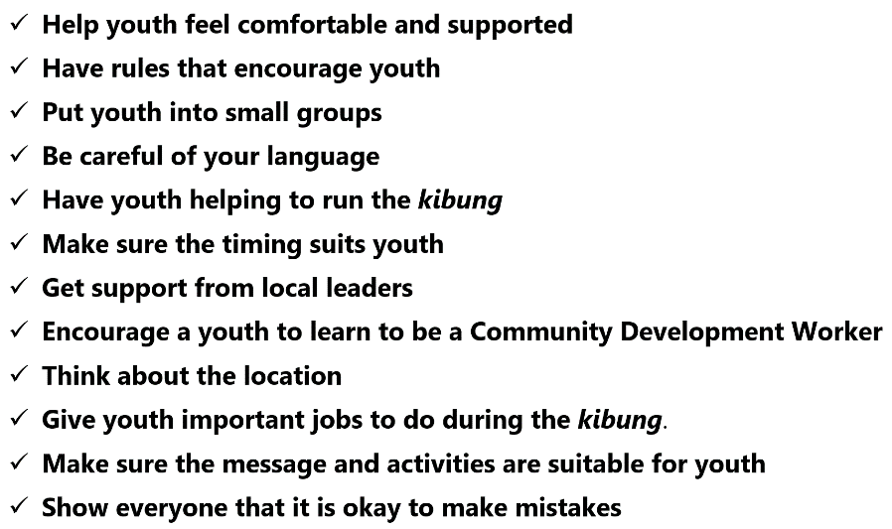

3 | Written answer  D  Tingim ples bilong yu. With your colleagues, discuss how helping key people to take the lead can help PNG. Next, in your exercise book, explain two reasons why helping key people to take the lead during the activities can help PNG.

A good answer from a CDW will probably include two of the following, but other answers are also fine:

- By encouraging key people to take the lead, you build their confidence as leaders.
- By encouraging key people to take the lead, you help them understand why and how to be a Community Development Workers.
- By encouraging key people to take the lead, they will have more ownership of the work you are doing. This means the work you are doing will be more successful
- By encouraging key people to take the lead, everyone else in the group or the community will feel that they can also do it. You make everyone feel more powerful.
- By encouraging key people to take the lead you are showing respect – as long as you don’t force key people to take the lead. Rispek emi bikpela samting.

4 | Written answer  E  With your colleagues, discuss why two-way communication is important. Next, in your exercise book, explain what two-way communication means.

A good answer from a CDW will be something like “two-way communication means you need to take turns to talk and give people time to respond”

3 | Written answer  F  With your colleagues, discuss how doing community entry properly (Element 2) before you start the work that you came to do will help you to work in a way that is appropriate to local culture when you go ahead and start the activities. Next, in your exercise book, write down two good points from your discussion.

A good answer from a CDW will probably include the following points, but other answers are also fine (if they are good answers):

- Showing respect to leaders and key people (by doing community entry properly) will mean you have a good relationship with them when you begin the activities.
- By making arrangements with leaders and key people before you begin the activities, it is more likely that when you do the work you have come to do (the activities) it will be done in a way that is appropriate to local culture.

2 | Written answer  G  In your exercise book write down the four conditions for a valid agreement (above). Raitim gut. Then tick () which condition for a valid agreement is achieved by this wok mak from the National Standard.

A good answer from a CDW is below:

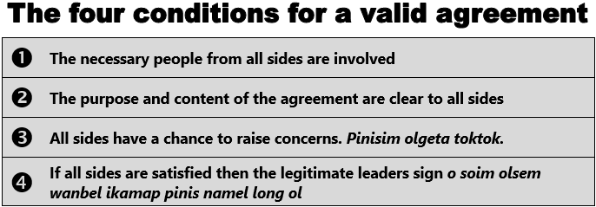

6 | Written answer  H  At the end of the coursebook is the Hasarai project plan ‘fewer teenagers damaged by drug abuse’. We looked at this in CDW Coursebook 3 (Participatory Planning). Tingim. Mama Kirap emi wanpela mama grup we iwok wok long go pas long projek. Na wanpela meri wok long go pas long halivim Mama Kirap na ol lain Hasarai long bihainim projek saikel. Her name is Merilyn. She is a Community Development Worker. The Buin District Government has agreed to fund the project, and want to sign a funding agreement. With your colleagues, have a good look at the Hasarai community project plan then discuss your answers to the following questions. When you have finished, write your answers in your exercise book.  - What agreements have already been made as part of developing the project plan?  - The Buin District Community Development Officer said that the District Administrator wants the key people from Hasarai to come to Buin District station to sign the funding agreement. What should Merilyn say? Why?  - Luk olsem for the funding agreement to be valid, everyone from Hasarai needs to be involved (not just the leaders and the key people). What can Merilyn do when she makes preparations (Element 1) and during community entry (Element 2) to make sure that lots of people from Hasarai attend the agreement discussion?  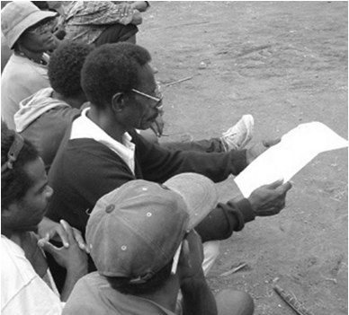

A good answer from a CDW is something like the following:

- 1. Asset-use agreement between Mama Kirap and Hasarai for use of resource centre
- 2. Merilyn should say that the agreement should be signed in Hasarai so that ol lain long ples can be a part of it. If it is signed at the District station people will be suspicious and start to say ino samting bilong mipela ino moa projek bilong mipela.
- 3. Make sure the timing is suitable. Make sure the invitation is sent early (and the tok save is done early). Make sure the venue is a good venue for everyone. Make sure it is clear that everyone is invited. Ask key people to help.

5 | Written answer  I  When you start the kibung to help the group kamapim wanbel (step 3 of the project cycle), you need to explain the purpose of the visit and why it is important that everyone in the group participates to facilitate agreements for a community activity. Discuss with your colleagues what you would do to put this wok mak into practice. Next, in your exercise book, write down two dot points to guide you when you go ahead and do it.

A answer from a CDW will include two good dot points to guide them. For example:

- When you explain the purpose of step 3 of the project cycle to everyone, it is a good idea to first give a clear explanation of the participatory project cycle so that everyone can see how it all fits together pisin lukluk kam daun.
- Many Community Development Workers explain the 6 steps of a participatory project cycle using the example of a family project cycle. This helps everyone connect it to their everyday lives.
- To inapim this wok mak, everyone needs to understand how participation by everyone in the group (not just the leaders and key people) makes the work more successful, supports inclusive development, and grows goodwill and trust namel long ol.

8 | Written answer  J  With your colleagues, have a go at making a good written agreement. Imagine you are a line manager, and your organisation wants to engage a trainer (a service-provider) to run training for a community organisation on something (you choose). Prepare a draft agreement that you could use when you facilitate the agreement. Keep it short and simple. When you have finished, write the draft agreement in your exercise book.

A good draft agreement from a CDW should demonstrate most of the following things:

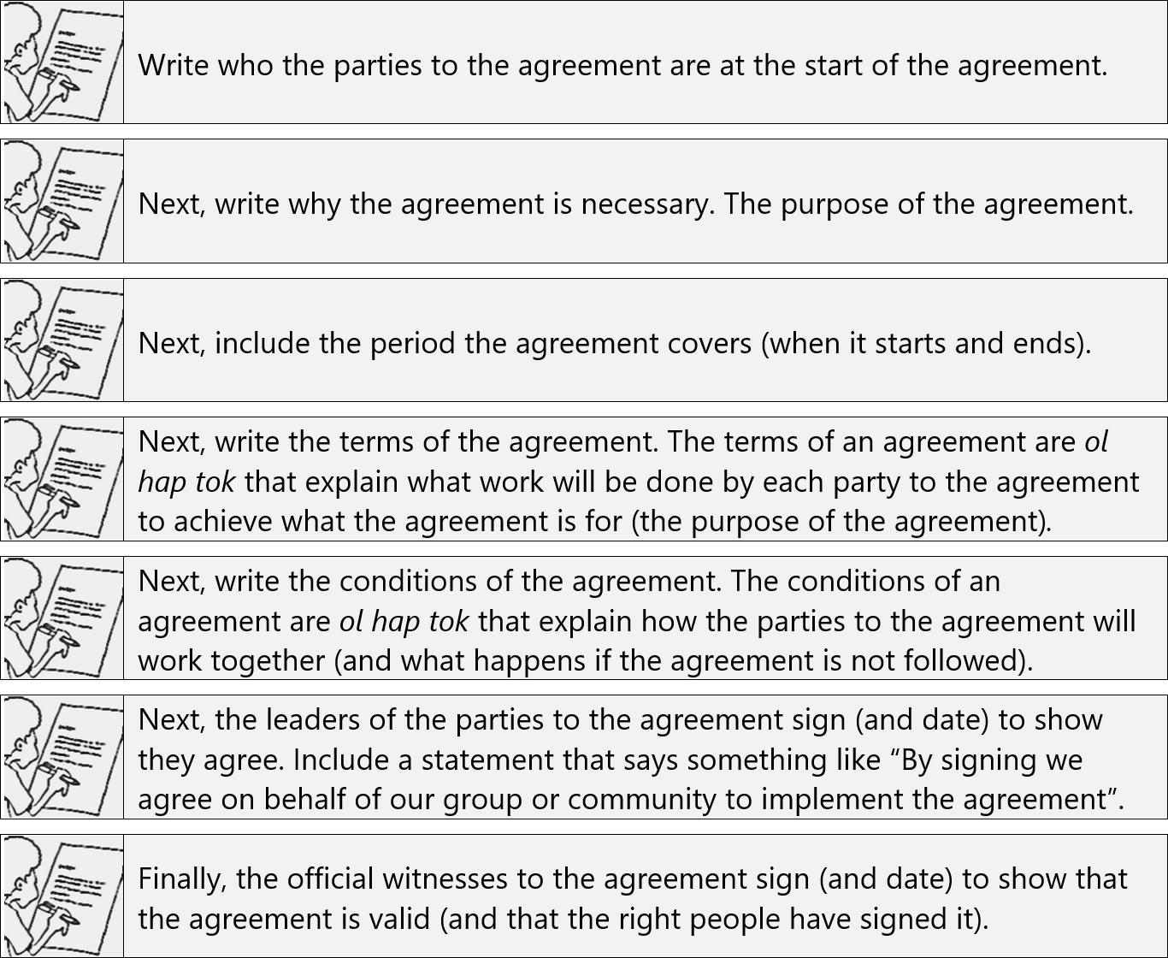

11 | Written answer  K  With your colleagues, discuss the two things you need to do to inapim this wok mak. Next, in your exercise book, write down the two things you need to do to inapim this wok mak. Finally, in your exercise book, write down the four conditions for a valid agreement again, and tick () which condition for a valid agreement is achieved by this wok mak from the National Standard.

A good answer from a CDW is below:

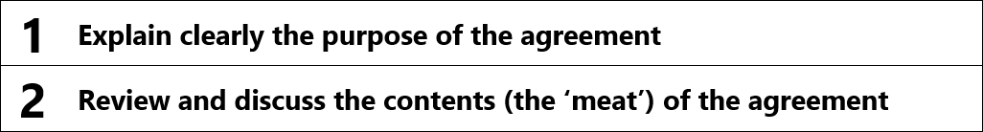

3 | Written answer  L  At the end of the coursebook, there are two ‘example cooperation agreements’. With your colleagues, look at example 1. It is a Memorandum of Understanding (MOU) between Okapa District and Ward 23 for drought relief. If you were facilitating this agreement long ples with the Ward 23 community, what focus groups would you put people into to help them identify and address any concerns? When you have finished, write your answer in your exercise book.

A good answer from a CDW is something like the following:

- Ward 23 women, Ward 23 men, Ward 23 young men, Ward 23 young women. It would also be a good idea to put the Okapa District Drought Relief Coordinator in a focus group along with any other people from outside the Ward 23 community. You could also put the Ward 23 Ward Development Committee in their own focus group. It would also be fine to just split everyone into focus groups of men and women.

5 | Written answer  M  With your colleagues, read and discuss the case study below then discuss the questions that follow. When you have finished, write your answers to the questions in your exercise book.  Rachael is a Community Development Worker working for Kopi Fama Sapot (KFS) – an NGO specializing in working with coffee smallholders. She has been sent to facilitate an agreement between KFS and the Pata Kopi Cooperative. The Agreement will allow the Pata Kopi Cooperative to access coffee-related training and will provide farmers with financial support to rehabilitate their coffee blocks. Funding from the KFS will be deposited to the cooperative’s account. The signatories to the account are the chairman and treasurer.  When Rachael arrives in Pata she meets with the chairman and treasurer of the cooperative. They say that most of the members are busy gardening but it’s okay to go ahead and sign the agreement now with the few people who are nearby. Rachael would like more people to be there but decides that it might embarrass the executives if she insists that they wait for other members. Rachael, the chairman, and the treasurer sit down on the veranda of the chairman’s house. Rachael reads through the agreement and then gets the two men to sign the agreement.  Discussion questions:  - Luk olsem this is not a valid agreement. Which of the four conditions for a valid agreement have not been satisfied or achieved?  - What problems might occur because the agreement is not a valid agreement?  - What should Rachael have said to the chairman and treasurer when they said it was okay to go ahead and sign the agreement (even though most of the members were busy gardening)?

A good answer from a CDW is something like the following:

- 1. None of the four conditions for a valid agreement have been satisfied or achieved.
- 2. Other members of Pati Kopi Cooperative may not recognize the agreement as valid. Other members may not understand what has been agreed to. The chairman and treasurer also may not properly understand because they have not benefited from the presence of other people to ask relevant questions. As account signatories, there will be a higher likelihood of misuse of funds by the chairman and treasurer. There will be more mistrust and jealousy and tok beksait.
- 3. Rachael should have apologized and politely insisted that the agreement process needed to be public and participatory so that the agreement could be considered valid. She should have also explained what problems might occur if they went ahead and signed an agreement that was not a valid agreement. She could also have said that it would not be in line with the National Standard for facilitating and agreement.

1 | Written answer  N  With your colleagues, discuss the final three wok mak that you need to put into practice when you help a group to facilitate and agreement. Next, in your exercise book, briefly explain each of the final three wok mak.

A good answer from a CDW is something like the following:

- Discuss what the next steps following the visit will be and who will be responsible for making them happen. It is always important to agree on what the next steps are, and who will be responsible for making them happen, before you finish facilitating the agreement.
- Discuss how or if the visit has been useful, and ways it could be improved. It is always important to find out if the work you did to help the group was useful. Learning from experience is the best teacher, but only if you learn lessons.
- Thank the group, without rushing, and explain again the purpose of the visit. It is always important to leave the community in the right way. Some Community Development Workers call this ‘community exit’. Take your time. Do it properly. Show respect. Remind everyone of what the visit was for (to facilitate an agreement).

1 | Written answer  O  With your colleagues, look again at topics 3.1, 3.2, 3.3, and 3.4 from Unit C04 Element 3 (at the start of this coursebook). Go through each topic again to refresh yourselves. Kirapim bek tinging. Next, in your exercise book, write the heading ‘Unit C03 Facilitate the start-up of a community activity’, and then underneath write the first four wok mak that you need to inapim (below).  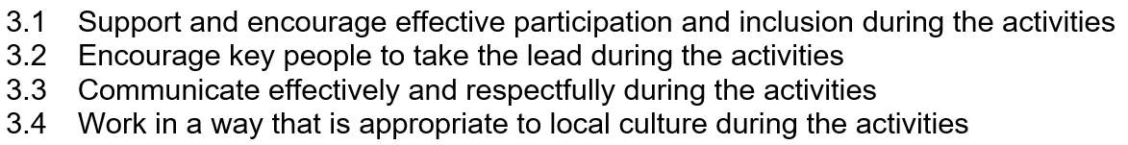

The CDW should have written the heading ‘Unit C03 Facilitate the start-up of a community activity’, and then underneath they should have written the following four performance criteria:

3.1 Support and encourage effective participation and inclusion during the activities

3.2 Encourage key people to take the lead during the activities

3.3 Communicate effectively and respectfully during the activities

3.4 Work in a way that is appropriate to local culture during the activities

2 | Written answer  P  In your exercise book write down the purpose of step 4 of the project cycle. Explain it in a way that ol lain long ples would understand.

A good answer from a CDW is something like the following:

- Project start-up is set gut na statim wok. Before you begin to implement the project everyone needs to come together again to make sure the plan is up-to-date and to skelim wok – who will be responsible for what, when it needs to happen, and what they will need. If everyone and everything is set gut redi long statim wok then the project will go more smoothly.

4 | Written answer  Q  With your colleagues, discuss why it is important to remind everyone why and how the project should strongim sindaun (if completed successfully). Next, in your exercise book, explain what Merilyn did to remind everyone why and how the project should strongim sindaun (if completed successfully).

A good answer from a CDW will be something like the following:

Merilyn used the Hasarai project tree and went through it again with everyone. The project tree contains the bones of a project plan - it shows why and how the project should strongim sindaun (if completed successfully).

3 | Written answer  R  With your colleagues, discuss what you need to do to inapim this wok mak. Next, in your exercise book write down why it is important to make sure all parties to any agreements are involved at the project start-up kibung.

A good answer from a CDW is below:

Because if only small changes need to be made to update any agreements, then if all parties to any agreements are involved at the project start-up kibung then you can make the changes. Also, if all parties are involved then everyone will be set gut redi long statim wok.

3 | Written answer  S  With your colleagues, discuss why you need to update the activity schedule and budget before beginning project start-up. Next, in your exercise book write down two dot points to guide you when you put this wok mak into practice.

A good answer from a CDW is below will include two dot points. For example:

Prepare a poster of each output outcome from the activity schedule. Then help everyone to go through each output outcome one-by-one to update and confirm it.

Go through the implementation schedule again (if there is one) and check. And it is also a good idea to include in the implementation schedule when everyone needs to come together for a monitoring kibung, and when everyone needs to come together to evaluate their project.

And go through the budget so everyone knows how the money will be spent

2 | Written answer  T  Helping a group to develop a community participation and support plan is one way to inapim this wok mak. With your colleagues, discuss how to help a group to develop a community participation and support plan. Next, in your exercise book, write down the three steps to help a group to do it

A good answer from a CDW is below:

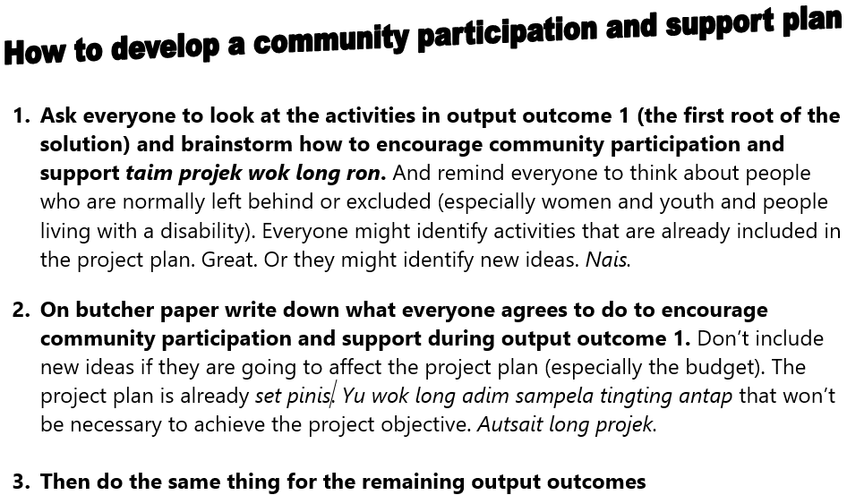

5 | Written answer  U  With your colleagues, discuss the final three wok mak that you need to put into practice when you help a group to start-up their project. Next, in your exercise book, write down the final three wok mak that you need to inapim.

A good answer from a CDW is:

- Discuss what the next steps following the visit will be and who will be responsible for making them happen
- Discuss how or if the visit has been useful, and ways it could be improved
- Thank the group, without rushing, and explain again the purpose of the visit

Written answer
V
Congratulations. You have finished CDW Coursebook 4. Time to evaluate coursebook 4. This is not a test. The purpose of these questions is for you (and your organisation and the course facilitator) to evaluate the learning experience that you have been through. With your colleagues, answer the questions below. Don’t forget to write your answers in your exercise book.

  - Which wok mak from CDW Unit C04 Element 3 (Facilitate agreement) or CDW Unit C03 Element 3 (Project start-up) are you most confused about? What are you confused about?
  - What topic in the coursebook did you find the most useful? Why?
  - What change do you recommend to improve the course or the coursebook?
  - What advice can you give to the course facilitator to help them learn lessons?
  - What more support do you need from your organisation (or the course facilitator) to help you put what you have learned into practice?
  - Any other comments?
  - Use the rating scale below to rate overall how well you understand how to facilitate an agreement in a way that meets the National Standard? Decide which face lines up with how you feel, then look at the letter above that face (A, B, C, D, or E), and write that letter as your answer.
  - Use the rating scale below to rate overall how well you understand how to start-up a project in a way that meets the National Standard? Decide which face lines up with how you feel, then look at the letter above that face (A, B, C, D, or E), and write that letter as your answer.

Finally, look at the answers the CDW has written for the evaluation questions. There is no right or wrong answer (as long as they have made an effort to answer the questions). You (the course facilitator) need to take note of what they have written because it will help you improve how you facilitate the course. If you need to write a report for your organisation, then you can use this evaluation information to help you. If you can, also get in touch with the PNG CDW Industry Technical Committee (ITC) through the ‘contact us’ link at pngcdwstandard.com and say that you want to send them the evaluation information. The PNG CDW ITC will get in touch with you by email and then you can email the evaluation information (or your report) to them. Doing this helps the PNG CDW ITC to improve the course and the coursebooks.

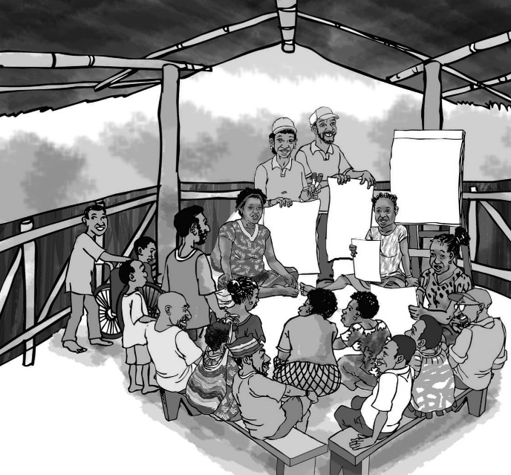

Sample written answers for CDW Coursebook 5

Below are the “written answer” questions from CDW coursebook 5. Underneath each question is an example of a good answer. Don’t forget, this is not a test. If a CDW has made a mistake or has a different answer, then it doesn’t mean they have failed. If they have tried their best to answer every question, then fine. But you definitely need to give feedback to the CDW, so they learn from their mistakes. The best way to do this is to meet with them and go through their answers one by one. If you can’t meet with them, then give them feedback on the phone or online.

2 | Written answer  A  With your colleagues, read the pamphlet on the PNG National Standard for CDWs (at the end of this coursebook). The National Standard lists 12 jobs (Units) that CDWs often do. Six of these 12 Units line up with the six steps of a project cycle. In your exercise books, write down which six Units line up with the six steps, and circle the two Units that we are going to look at in this coursebook.

A good answer from a CDW is below:

Step 1 Assist group to analyse their development situation and identify priorities (glasim na skelim sindaun)

Step 2 Assist group to develop a project plan for a community activity (kamapim projek plen)

Step 3 Facilitate agreements for a community activity (kamapim wanbel)

Step 4 Facilitate the start-up of a community activity (set gut na statim wok)

Step 5 Monitor community activity (sekim wok)
Step 6 Evaluate community activity outcomes (lukluk bek na skelim)

2 | Written answer  B  With your colleagues, write the coursebook objective on a poster na putim long ples klia. Leave it long ples klia until you complete this coursebook. For CDW Coursebook 5 (this coursebook) the objective is Understand how to help a group to monitor a community activity (step 5 of the project cycle) and evaluate community activity outcomes (step 6 of the project cycle) in a way that meets the Standard. Next, in your exercise book, write the coursebook objective in big letters.

A good answer from a CDW is:

- Understand how to help a group to monitor a community activity (step 5 of the project cycle) and evaluate community activity outcomes (step 6 of the project cycle) in a way that meets the Standard

3 | Written answer  C  With your colleagues, discuss ways to support and encourage women, youth, and people living with a disability to participate effectively during a kibung. Next, in your exercise book, write down five things you plan to do to support and encourage people living with a disability to participate effectively next time you facilitate a kibung.

A good answer from a CDW will include five good points. The following are only examples:

- Make sure everyone understands how they will benefit from the activities. If women and youth and people living with a disability know they will also benefit from the work you are helping the group to do (for example, a project), then they are more likely to get involved and contribute their ideas.
- Help everyone feel comfortable and supported. Be encouraging, friendly, respectful, and understanding. Always.
- Think about how to get everyone involved when you prepare your work plan. Think hard about how you can include content and activities that are suitable for women and youth and people living with a disability.
- Have rules that help women and youth and people living with a disability to participate. Women need to know they will not be shouted at or put down. Youth need to know that they will not be told to pasim maus. People living with disabilities need to know they have the right to get involved and contribute ideas.
- Select the least powerful and least confident to take on responsibility. By selecting people who might otherwise stay quiet to have (small) roles, you demonstrate your confidence in them, and this in turn increases their confidence and the likelihood that they will contribute their ideas. For example, make a woman the timekeeper or a youth the person who says the prayer.
- Get the most powerful and confident to step back. As a Community Development Worker, you often need to try and get the message across to the most powerful and confident people to step back and let other people have a turn.
- Use inclusive language. Noken tok “man” - tok “manmeri”. This makes it clear to women that they also belong at the kibung. Na tu noken tok “manmeri”, tok “manmeri na ol yangpela” – so youth know that they also belong.
- Consider having a translator. Often people who need the most support and encouragement are those who only understand tok ples.
- Have a woman or youth or person living with a disability as co-facilitators. It helps to facilitate a kibung if you have people to help you. This is because you can give each other confidence and share the workload. If you have a woman or a youth or a person living with a disability on the team, then other women and youth and people living with a disability should be more motivated and confident. AND it teaches the leaders of the future (our young men and women) what to do.
- Make sure the timing suits everyone. For example, women have many responsibilities (just like men) so it is important to make sure the timing of the kibung also suits women. If it doesn’t, they may be anxious about their other responsibilities, and they won’t feel comfortable. If the kibung is on at the same time as a volleyball tournament, then the interest of the youth might be elsewhere.
- Welcome babies and children. Women participants often have young children with them. Make sure the young children are welcomed so that their mothers don’t feel anxious. And make sure women feel comfortable to leave if they need to look after their children’s needs. Or ask the key people (during community entry) to arrange a babysitter to look after children so mothers (and fathers) can concentrate.
- Use small group activities and role plays to help everyone feel comfortable. Many people feel more confident in smaller groups, particularly if you put them in groups with other people that they feel comfortable with. For example, you may like to get men and women into separate small groups to discuss what their priorities are to improve health. Often women and youth and people living with a disability are more confident in role plays because they can pretend to be someone else.
- Select an appropriate venue. If you hold the kibung in a traditional place, then women and youth and people living with a disability may act in the way that kastom tells them to act. Work with key people to select a venue where everyone feels comfortable getting involved and contribute their ideas. Make sure it is accessible for people living with a disability. And it is especially important to make sure the venue is in a place where everyone feels safe.
- Have good clean toilets and water (and food). It can be hard to concentrate and get involved if you need to use the toilet, or if you are thirsty (or hungry).
- Get key people to help everyone get involved and share their ideas. Key people can help you to make sure women and youth and people living with a disability are included during a kibung (or other activities).
- Make it clear that it is okay to make mistakes. It is very important that everyone feels it is okay to make mistakes (so they are more confident to have a go). A good way to do this is by showing everyone that you are not afraid to make mistakes yourself. Laugh when you make a mistake – don’t be a bik het and try to cover it up. Community Development Workers who pretend they know everything make everyone else feel like they know nothing.
- Move around the venue. Move around the venue so that people at the back and side are also involved. Often people arrange themselves in a kibung so that women and youth and people living with a disability are together in a group – if you move around the venue, you can make these different groups the focus of your attention.
- Use local materials that are familiar to the participants. Using local materials help people connect what they are doing to their everyday lives – they become more interested and more confident. Tingting save op. Tingting save kirap.
- Acknowledge the contribution of everyone at the end of the activities. Remind everyone that women and youth and people living with a disability were all involved and contributed their ideas. Hopefully, everyone else sees that women and youth and people living with a disability can do it (and it helped). This lesson is powerful.

3 | Written answer  D  With your colleagues, discuss how seeing key people from their community taking the lead helps the next generation. Senis bilong yumi. Next, in your exercise book, write down two good points from your discussion.

A good answer from a CDW will include two good points. The following are examples only:

- By encouraging key people to take the lead, you build their confidence as leaders.
- By encouraging key people to take the lead, you help them understand why and how to be a Community Development Workers.
- By encouraging key people to take the lead, they will have more ownership of the work you are doing. This means the work you are doing will be more successful
- By encouraging key people to take the lead, everyone else in the group or the community will feel that they can also do it. You make everyone feel more powerful.
- By encouraging key people to take the lead you are showing respect – as long as you don’t force key people to take the lead. Rispek emi bikpela samting.

4 | Written answer  E  With your colleagues, discuss what can go wrong if you use big words and ‘expensive’ English when you work with a grup long ples. Next, in your exercise book, write down three things that can go wrong if you use big words and ‘expensive’ English when you work with a grup long ples.

A good answer from a CDW will be similar to the following:

If you use big words and ’expensive’ English, you will lose the trust of the people you are working with. You make them feel less than you. You make them feel like they can’t do it themselves. They won’t understand you, so the work won’t go as well. If things go wrong, they will point fingers at you. And you make the gap that is opening between formally educated elites and everyone even wider.

3 | Written answer  F  With your colleagues, discuss what can go wrong if a Community Development Worker doesn’t show respect for local culture. Next, in your exercise book, explain two things that can go wrong if a Community Development Worker doesn’t show respect for local culture when they work with a group.

A good answer from a CDW will include points like the following:

- They will lose the respect of the community and the leaders.
- Their work won’t go well
- If something goes wrong, people will point fingers at them
- They could find themselves in an unsafe position
- They won’t be able to return

4 | Written answer  G  When you start the kibung to help the group sekim wok (step 5 of the project cycle), you need to explain the purpose of the visit and why it is important that everyone in the group participates to monitor their project. Discuss with your colleagues what you would do to put this wok mak into practice. Next, in your exercise book, write down three dot points to guide you when you go ahead and do it.

A good answer from a CDW is something like the following:

- When you explain the purpose of step 5 of the project cycle to everyone, it is a good idea to first give a clear explanation of the participatory project cycle so that everyone can see how it all fits together pisin lukluk kam daun. Many Community Development Workers explain the 6 steps of a participatory project cycle using the example of a family project cycle. This helps everyone connect it to their everyday lives.
- To inapim this wok mak, everyone needs to understand how participation by everyone in the group (not just the leaders and key people) makes the work more successful, supports inclusive development, and grows goodwill and trust namel long ol.

4 | Written answer  H  With your colleagues, discuss why it is important to remind everyone why and how the project should strongim sindaun (if completed successfully) before helping them to check on how things are going with the project (monitoring). Next, in your exercise book, explain what Merilyn did to remind everyone why and how the project should strongim sindaun (if completed successfully).

A good answer from a CDW will be something like the following:

Merilyn used the Hasarai project tree and went through it again with everyone. The project tree contains the bones of a project plan - it shows why and how the project should strongim sindaun (if completed successfully).

4 | Written answer  I  With your colleagues, discuss how to work with the group to check progress against the activity schedule. Next, in your exercise book, answer the following question: When you go through the activity schedule with everyone, when should you put a question mark next to the activity?

A good answer from a CDW is something like the following:

- You should put a question mark next to the activity if the activity has been partly completed or if something has gone wrong or if something needs follow-up. Sometimes there will be disagreement about whether an activity has been completed. If there is no consensus that the activity is completed, then put a question mark.

2 | Written answer  J  In your exercise book write down the four things you need to do during the monitoring investigation. Raitim gut.

A good answer from a CDW is something like the following:

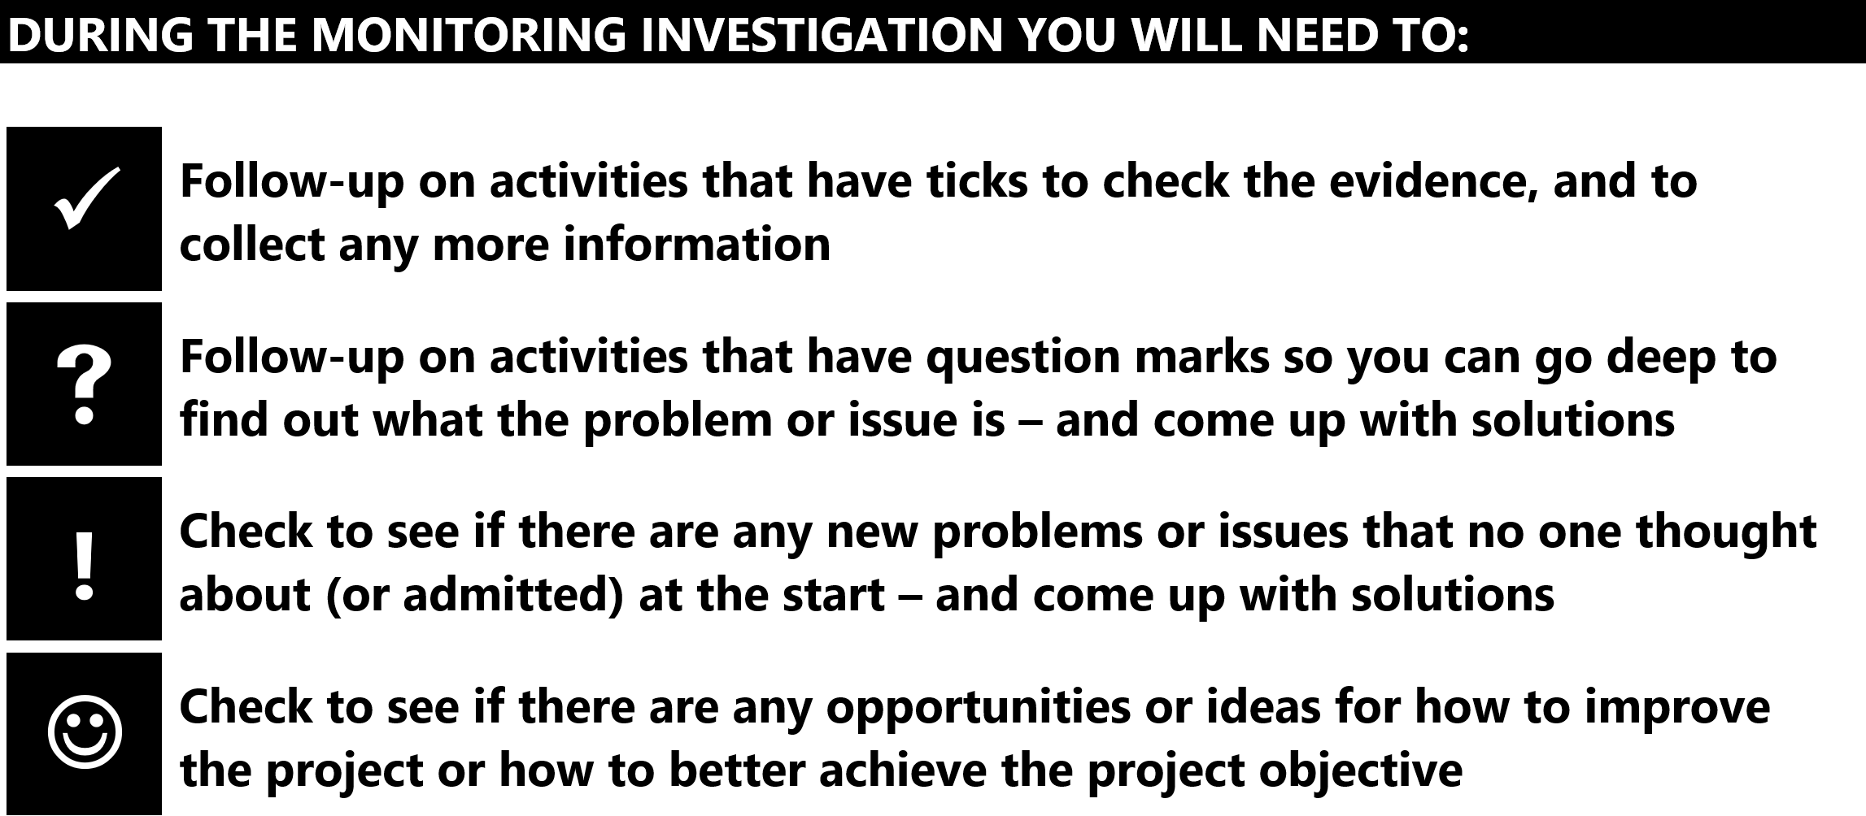

6 | Written answer  K  With your colleagues, discuss how to use interviews, focus groups, and village walks to conduct the monitoring investigation. Next, in your exercise book, write down the three tools you can use to conduct the monitoring investigation (interviews, focus groups, village walks) and for each tool write down how to use it.

A good answer from a CDW is something like the following:

- Interviews. An interview involves the CDW sitting down and talking with one (or two) people. Before you sit down with the person you want to interview, it is much better if you think about the key questions you want to ask or the topics you want to cover – this gives the interview structure. In an interview, you can investigate how successful implementation has been by asking the person for their opinion on the success of activities. Wanem tingting bilong yu? What is working? What problems or issues have you noticed? What solutions do you have? What ideas do you have? What worries you? What stories can you share? Who else should we talk to? Kain kain.
- Focus groups. CDWs always use focus groups to conduct the monitoring investigation. Focus groups need to be planned. This means you need to think about who you want in the focus group. Normally (but not always) the people in the focus group have something in common. For example, they are all young women or all members of the basketball team or all members from one family. Focus groups should have structure. This means you need to think about the key questions you want to ask or topics you want to cover during the focus group.
- Village walks. Go for a walk to see the results of the activities. It is good to do this with a focus group or after (or during) an interview – but it can be done anytime. Any time you have free time then go for a walk to look at something and talk as you go. A village walk will encourage people to talk openly. Most people find it easiest to talk in a relaxed and informal situation – such as going for a walk. A village walk is also a chance for the CDW to learn about the local area and the people. You get a context (a background) so you can understand what people are saying about their sindaun.

1 | Written answer  L  In your exercise book, write down the three steps that most CDWs take (above) during a monitoring visit. Raitim gut.

A good answer from a CDW is something like the following:

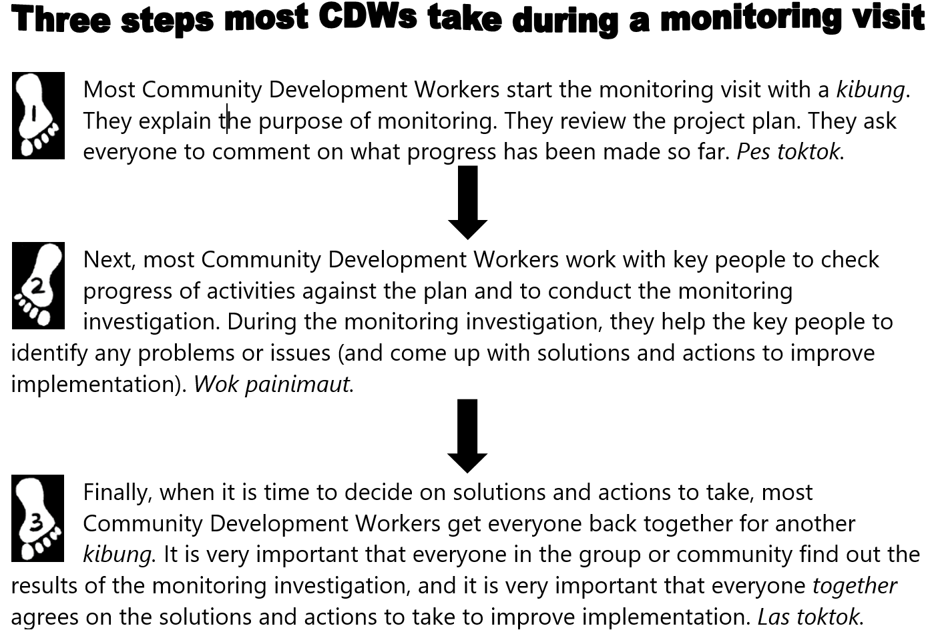

3 | Written answer  M  With your colleagues, discuss how you would make sure that women and youth and people living with a disability are included when everyone decides on solutions and actions to improve implementation and how to put them into practice. Next, in your exercise book, write down your answer.

A good answer from a CDW is probably something like the following, but a different answer is fine as long as you think it is a good way for women and youth and people living with a disability to be included:

- If you want to make sure that women and youth and people living with a disability have their voices heard, then a good idea is to split everyone into smaller groups – meri, man, yut meri, yut man – to discuss what to do about a problem or issue, and what solutions or actions to take. If you think it is necessary, you can also have a group just with people living with a disability. Then get each small group to report back what they discussed. Then, get everyone to come back together to see if the whole group can agree on a decision.

1 | Written answer  N  With your colleagues, discuss the final three wok mak that you need to put into practice when you help a group to monitor their project. Next, in your exercise book, briefly explain each of the final three wok mak.

A good answer from a CDW is something like the following:

- Discuss what the next steps following the visit will be and who will be responsible for making them happen. It is always important to agree on what the next steps are, and who will be responsible for making them happen, before you finish the monitoring visit.
- Discuss how or if the visit has been useful, and ways it could be improved. It is always important to find out if the work you did to help the group was useful. Learning from experience is the best teacher, but only if you learn lessons.
- Thank the group, without rushing, and explain again the purpose of the visit. It is always important to leave the community in the right way. Some Community Development Workers call this ‘community exit’. Take your time. Do it properly. Show respect. Remind everyone of what the monitoring visit was for.

1 | Written answer  O  With your colleagues, look at topics 3.1, 3.2, 3.3, and 3.4 from Element 3 Unit C02 (at the start of this coursebook). Go through each topic again to refresh yourselves. Kirapim bek tinging. Next, in your exercise book, write the heading ‘Unit C08 Evaluate community activity outcomes’, and then underneath write the first four wok mak that you need to inapim (below).

The CDW should have written the heading ‘Unit C08 Evaluate activity outcomes’, and then underneath they should have written the following four performance criteria:

3.1 Support and encourage effective participation and inclusion during the activities

3.2 Encourage key people to take the lead during the activities

3.3 Communicate effectively and respectfully during the activities

3.4 Work in a way that is appropriate to local culture during the activities

2 | Written answer  P  In your exercise book write down the purpose of step 6 of the project cycle. Explain it in a way that ol lain long ples would understand.

A good answer from a CDW is probably something like the following:

- Evaluation is lukluk bek na skelim. Evaluation is done some time after the project is completed to see what the project achieved, and to learn lessons. Lessons for the group or community, lessons for the key people, lessons for any outside organisation, and lessons for the CDW. Projek ikarim wanem kaikai? Swit bilong en em olsem wanem? Wanem leson long lainim? Na hau bai yumi kaikai gutpela kaikai bilong en igo yet?

3 | Written answer  Q  With your colleagues, discuss why it is important to remind everyone why and how the project was supposed to strongim sindaun before helping them to evaluate their project. Next, in your exercise book, explain what Merilyn did to remind everyone why and how the project was supposed to strongim sindaun.  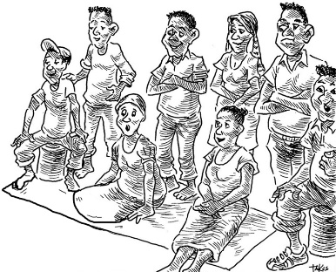

A good answer from a CDW will be something like the following:

- Merilyn used the Hasarai project tree and went through it again with everyone. The project tree contains the bones of a project plan - it shows why and how the project should strongim sindaun (if completed successfully).

4 | Written answer  R  With your colleagues, discuss how to work with stakeholders to identify the actual project outcomes. Next, in your exercise book, first explain what the difference is between expected project outcomes and actual project outcomes. Then write down which focus groups are good to put people into to identify the actual project outcomes. Finally, write down the two questions that Merilyn asked the focus groups to discuss (to help them identify the actual project outcomes).

A good answer from a CDW is probably something like the following:

- The expected project outcomes are what everyone expected would come out of the project when they developed the project plan. The actual project outcomes are the benefits (and problems) that actually came out of the project.
- What focus groups you use will depend on the project and the group or community you are working with. Most Community Development Workers make sure that (1) the direct beneficiaries of the project (the people targeted by the people-centred project objective), (2) men, and (3) women are in separate focus groups. If you can, it is also a good idea to put (4) young men, and (5) young women into separate focus groups.
- The two questions to ask focus groups (to help them identify the actual project outcomes) are (1) Wanem gutpela bin kamaut long projek? (2) Wanem nogut o hevi bin kamaut long projek?

1 | Written answer  S  With your colleagues, discuss what Merilyn did to help stakeholders to evaluate the impact of actual project outcomes. Next, in your exercise book, write down some dot points to guide you when you put this wok mak into practice.

A good answer from a CDW will be similar to the following:

- Merilyn kept everyone in the same focus groups. She then asked everyone to use a five-level rating scale to rate the impact of the actual project outcomes, and how well the project objective was achieved

4 | Written answer  T  With your colleagues, discuss which rating scale is best for the groups or communities that you work with to rate how well the project objective has been achieved. Would you use a five-level or a three-level rating scale? Would you use rating sticks or mobile phone bars or smiley faces or something else? Next, in your exercise book, explain the rating scale you think you will use.  

Check that the CDW has given some thought to what would be a good rating scale for them to use with the groups and communities they work with.

2 | Written answer  U  With your colleagues, discuss the 3 things that a CDW needs to do (with the key people) during the evaluation investigation. Next, in your exercise book, write down the 3 things that a CDW needs to do during the evaluation investigation.

A good answer from a CDW is something like the following:

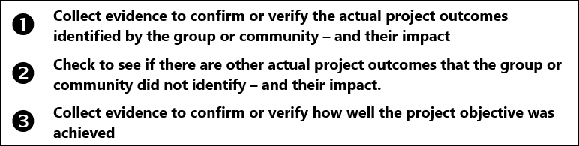

3 | Written answer  V  With your colleagues, discuss which tools (interviews, focus groups, village walks, ranking, significant change story) you could use to do each of the three things that a CDW needs to do during the evaluation investigation (below).  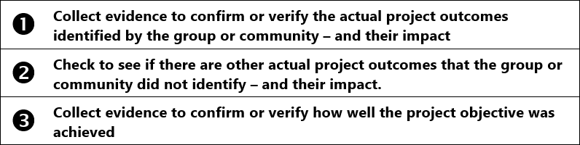    Next, in your exercise book, explain how to use the tools (1) ranking and (2) significant change story, and give an example of how you could use each tool during the evaluation investigation.

A good answer from a CDW is probably something like the following:

- Ranking is normally used in a focus group to help everyone put a list of items into an order (or rank). For example, during a focus group, women might have listed down different ways the health of children has been improved by a project. It would be useful to know how significant the health benefits have been (from most significant to least significant). To use the ranking tool, write down all the items that have been identified on paper or post-it notes and then everyone can discuss and argue and rearrange until there is consensus on how to rank the items. You can have more than one item on the same rank - for example, there can be two items in second place.
- Significant change story. When you are conducting the evaluation investigation (or anytime) if someone tells you a story about a change (good or bad) that happened because of the project then write it down. In particular, write down stories that you hear about changes that happened to the direct beneficiaries of the project (the people targeted by your people-centred project objective). Funding organisations like to read significant change stories because positive change to the lives of the direct beneficiaries is what they hoped their money would achieve.

5 | Written answer  W  With your colleagues, discuss how to work with stakeholders to learn lessons from the evaluation. Next, in your exercise book, write down the two questions to help everyone learn lessons (above) and translate them into simple English.

A good answer from a CDW is probably something like the following:

Tingim projek saikel long stat ikam inap. Wanem wanem ol samting bin halavim projek long karim kaikai? Bai yumi lainim wanem long dispela?

Translation: “Think about the project cycle from the start to the finish. What things helped the project to be successful? What lessons can we learn from this?”

Tingim projek saikel long stat ikam inap. Wanem wanem ol samting bin mekim hat long projek long karim kaikai? Bai yumi lainim wanem long dispela?

Translation: “Think about the project cycle from the start to the finish. What things made it hard for the project to be successful? What lessons can we learn from this?”

3 | Written answer  X  With your colleagues, discuss the final three wok mak that you need to put into practice when you help a group or community to evaluate their project. Next, in your exercise book, write down the final three wok mak that you need to inapim if you want to conduct evaluation in a way that meets the Standard.

A good answer from a CDW is:

- Discuss what the next steps following the visit will be and who will be responsible for making them happen
- Discuss how or if the visit has been useful, and ways it could be improved
- Thank the group, without rushing, and explain again the purpose of the visit

Written answer
Y
Congratulations. You have finished CDW Coursebook 5. This is the final CDW coursebook. Time to evaluate CDW Coursebook 5. This is not a test. The purpose of these questions is for you (and your organisation and the course facilitator) to evaluate the learning experience that you have been through. With your colleagues, answer the questions below. Don’t forget to write your answers in your exercise book.

  - Which wok mak from CDW Unit C02 Element 3 (Monitor community activity) or CDW Unit C08 Element 3 (Evaluate community activity outcomes) are you most confused about? What are you confused about?
  - What topic in the coursebook did you find the most useful? Why?
  - What change do you recommend to improve the course or the coursebook?
  - What advice can you give to the course facilitator to help them learn lessons?
  - What more support do you need from your organisation (or the course facilitator) to help you put what you have learned into practice?
  - Any other comments?
  - Use the rating scale below to rate overall how well you understand how to conduct monitoring in a way that meets the National Standard? Decide which face lines up with how you feel, then look at the letter above that face (A, B, C, D, or E), and write that letter as your answer.
  - Use the rating scale below to rate overall how well you understand how to conduct evaluation in a way that meets the National Standard? Decide which face lines up with how you feel, then look at the letter above that face (A, B, C, D, or E), and write that letter as your answer.

Finally, look at the answers the CDW has written for the evaluation questions. There is no right or wrong answer (as long as they have made an effort to answer the questions). You (the course facilitator) need to take note of what they have written because it will help you improve how you facilitate the course. If you need to write a report for your organisation, then you can use this evaluation information to help you. If you can, also get in touch with the PNG CDW Industry Technical Committee (ITC) through the ‘contact us’ link at pngcdwstandard.com and say that you want to send them the evaluation information. The PNG CDW ITC will get in touch with you by email and then you can email the evaluation information (or your report) to them. Doing this helps the PNG CDW ITC to improve the course and the coursebooks.
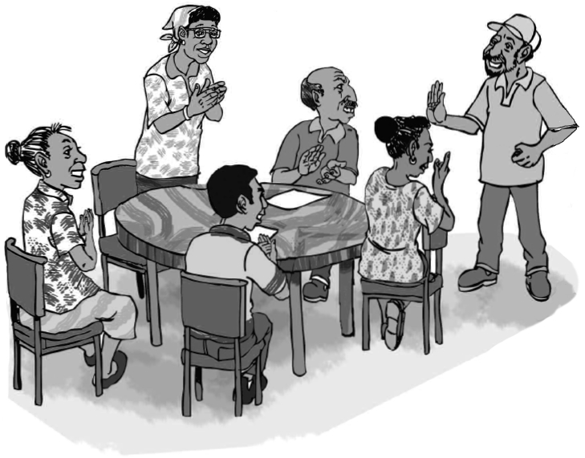
Sample written answers for CDW Coursebook 6

Below are the “written answer” questions from CDW coursebook 6. Underneath each question is an example of a good answer. Don’t forget, this is not a test. If a CDW has made a mistake or has a different answer, then it doesn’t mean they have failed. If they have tried their best to answer every question, then fine. But you definitely need to give feedback to the CDW, so they learn from their mistakes. The best way to do this is to meet with them and go through their answers one by one. If you can’t meet with them, then give them feedback on the phone or online.

2 | Written answer  A  With your colleagues, write the coursebook objective on a poster na putim long ples klia. Leave it long ples klia until you complete this coursebook. For CDW coursebook 6 (this coursebook) the objective is to Understand how to provide mentoring in a way that meets the Standard. Next, in your exercise book, write the coursebook objective and underline it (or circle it).

A good answer from a CDW is:

- Understand how to provide mentoring in a way that meets the Standard

3 | Written answer  B  With your colleagues, discuss the role of the mentor and the role of the mentees. Next, in your exercise book, do the following:  - Write down the role of a mentor.  - Write down the role of the mentees.  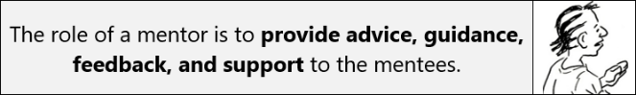

A good answer from a CDW is:

- The role of a mentor is to provide advice, guidance, feedback, and support to the mentees.
- The role of the mentees is to be ready to learn, motivated, honest, open, and committed.

5 | Written answer  C  With your colleagues, have a go at writing a mentoring agreement between Sally (the mentor) and Robert (the mentee). Sally will be mentoring Robert so he knows how (and why) to brush his teeth properly. Keep it simple and make it easy to understand. Em bilong kisim aidia tasol. When you have finished, put a copy of the mentoring agreement in your exercise book.

A good answer from a CDW is:

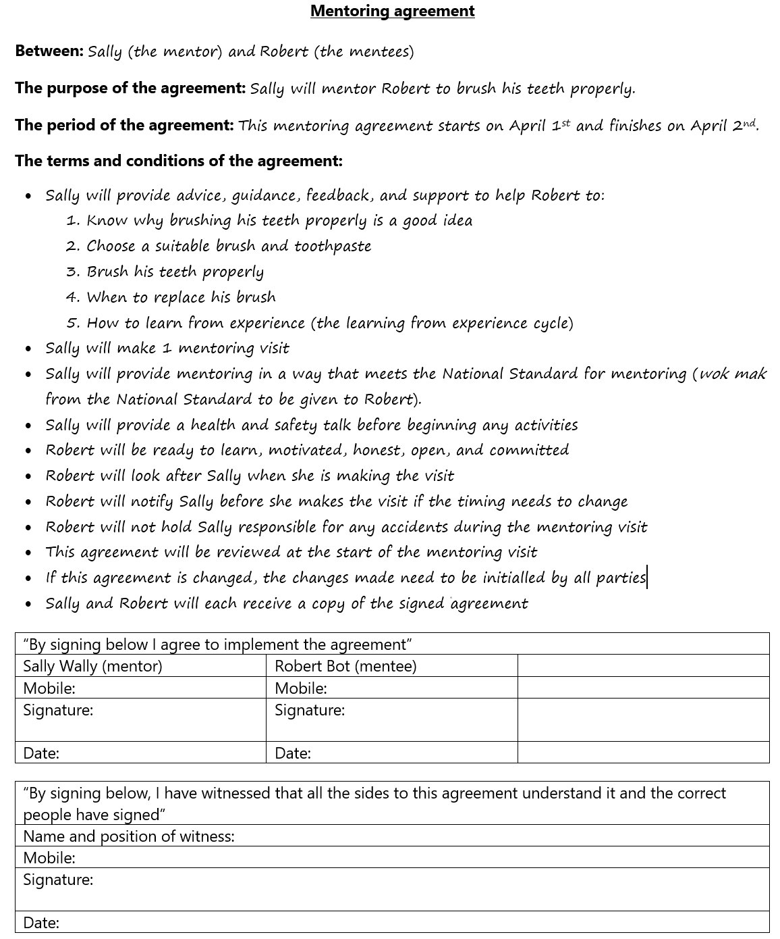

3 | Written answer  D  Assisting the mentees to go through a learning from experience cycle is a good model for mentoring. With your colleagues, discuss how to help mentees to go through a learning from experience cycle. When you finish, write this wok mak in your exercise book and copy the learning from experience cycle below it.

A good answer from a CDW is:

- Assist the mentees to reflect on what they are doing, learn lessons, and plan how to put the lessons into practice

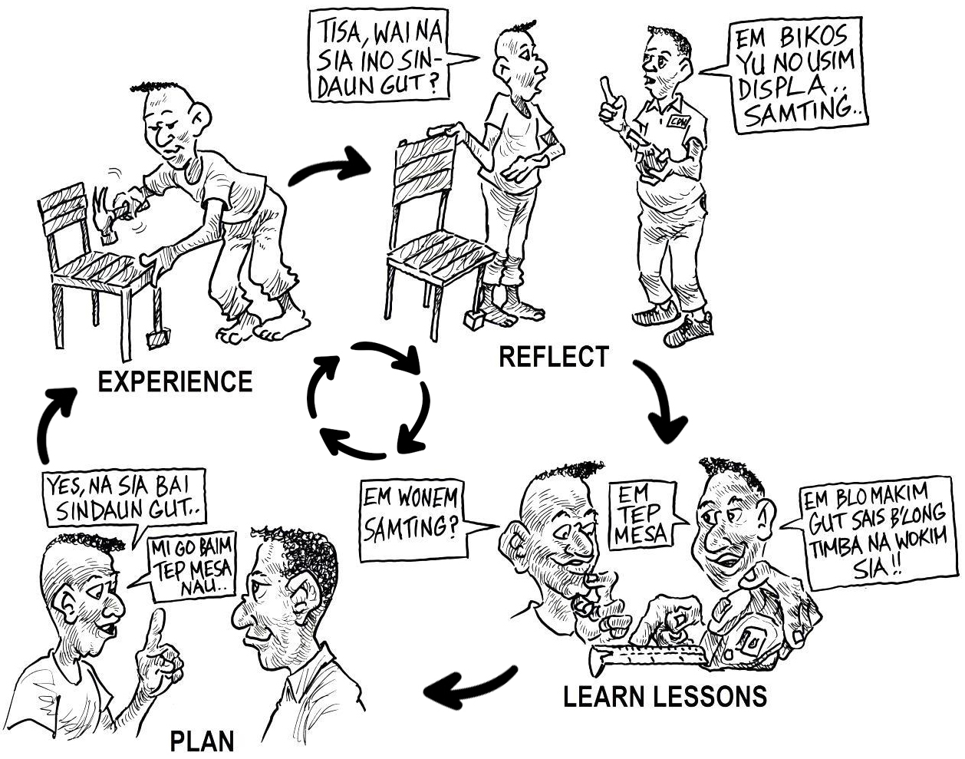

2 | Written answer  E  With your colleagues, discuss what you can do to put principle 1 into practice (adults learn better if it helps solve a problem they are facing). When you have finished, write this principle (principle 1) in your exercise book, and then write down how helping the mentees to go through a learning from experience cycle will help you to put this principle of adult learning into practice.

A good answer from a CDW is:

- Principle 1 is: Adults learn better if it helps solve a problem they are facing (problem-solving learning). Helping the mentees to go through a learning from experience cycle will help mentees to learn because when they REFELCT on what they are doing they identify what problems they are having – and this makes what they learn to help solve this problem easier to learn and remember.

3 | Written answer  F  With your colleagues, discuss what you can do to put principle 2 into practice (adults learn better if they helped decide what they need to learn). When you have finished, write this principle in your exercise book, and then write down how helping the mentees to go through a learning from experience cycle will help you to put this principle of adult learning into practice.

A good answer from a CDW is:

- Principle 2 is: Adults learn better if they helped decide what they need to learn (learner-led learning). Helping the mentees to go through a learning from experience cycle will help mentees to learn because they are the ones who decide or agree what lessons need to be learned.

4 | Written answer  G  With your colleagues, discuss what you can do to put principle 3 into practice (adults learn better if they feel comfortable, confident and respected). When you finish, write this principle in your exercise book, and then write down 10 things you can do when you provide mentoring to put this principle into practice.

A good answer from a CDW is:

- Principle 3 is: Adults learn better if they feel comfortable, confident and respected (learning as equals). Examples of 10 things you can do when you provide mentoring to put this principle into practice are:
- Make sure the mentees feel comfortable
- Help the mentees feel confident
- Say thankyou
- Empathise and show interest
- Don’t use jargon and ‘expensive’ English
- Use a translator if necessary
- Respect local culture (we will learn about this later olsem na stap isi pastaim)
- Listen carefully to what the mentees say – and always respond
- Providing the mentoring in their ples.
- Ask the mentees to give you help and advice.

5 | Written answer  H  With your colleagues, discuss what you can do to put principle 4 into practice (adults learn better in the place where they will use what they learn). When you have finished, write this principle in your exercise book, and then write down 1 thing you can do when you provide mentoring to put this principle into practice.

A good answer from a CDW is:

- Principle 4 is: Adults learn better in the place where they will use what they learn (situated learning). One thing you can do to put this principle into practice is make sure you provide the mentoring in their ples (the place where they will use what they learn).

6 | Written answer  I  With your colleagues, discuss what you can do to put principle 5 into practice (adults learn better if it connects to what they already know and do). When you have finished, write this principle in your exercise book, and then write down 3 things you can do when you provide mentoring to put this principle into practice.

A good answer from a CDW is:

- Principle 5 is: Adults learn better if it connects to what they already know and do (connected learning). Three things you can do to put this principle into practice when you provide mentoring are:
- Always try and provide mentoring in the mentees community. Definitely.
- Listen carefully and observe what is around you
- When you give help or advice, ask the mentees how they can use it and what problems or challenges they might face (and what they can do about it).

7 | Written answer  J  With your colleagues, discuss what you can do to put principle 6 into practice (adults learn better if they use more than one of their senses). When you have finished, write this principle in your exercise book, and then write down 3 things you can do when you provide mentoring to put this principle into practice.

A good answer from a CDW is:

- Principle 6 is: Adults learn better if they use more than one of their senses (multi-sensory learning). Three things you can do to put this principle into practice when you provide mentoring are:
- As you TELL new information to mentees, you could ask them to look at a poster or a picture or point at something so they can also SEE and learn with their eyes.
- As you TELL new information to mentees, you could use body language to emphasise key points so they also SEE and learn with their eyes.
- As you TELL new information to mentees, you could do a practical demonstration so they also SEE and learn with their eyes.

8 | Written answer  K  With your colleagues, discuss what you can do to put principle 7 into practice (adults learn better if they use what they learn to do something). When you have finished, write this principle in your exercise book, and then write down 3 things you can do when you provide mentoring to put this principle into practice.  Save moa yet. This ‘written answer’ question is principle 7 in action. Tingim. In this coursebook (and in all the CDW coursebooks), you will notice that the information you need to learn is broken up into steps (for example, the number on the left shows that this is step 8) and each step is broken further into hap step. Two or three short paragraphs of information o kain olsem. After each hap step there is normally a discussion or activity or written answer (like this one) where you need to do something with the information you have just learned in the hap step. This is principle 7 in action – getting you to use what you have just learned to do something.

A good answer from a CDW is:

- Principle 7 is: Adults learn better if they use what they learn to do something (learning by doing). Three things you can do to put this principle into practice when you provide mentoring are:
- After they learn something, get the mentees to do a practical activity.
- After they learn something, ask the mentees a question about what they learned
- After they learn something, get the mentees to write down what they learned in their own words or a different language.

10 | Written answer  L  With your colleagues, discuss the four-step lesson plan. When you have finished, copy the four-step lesson plan into your exercise book. When you do this, write it in your own words or tok ples o tok pisin o tok motu.  

A good answer from a CDW is:

Foapela hap step leson plen
- Tok igo pas
- Kliarim ol gut tru pastaim
- Givim wok long ol long mek yus long wanem samting ol i lainim
- Lukluk bek na kirapim bek

13 | Written answer  M  With your colleagues, go through each of the 11 methods or techniques (above). Make sure you are clear on how to use them. When you have finished, write down this wok mak in your exercise book, and then write down the 11 methods or techniques. If you know any other methods or techniques, then add them to the list.  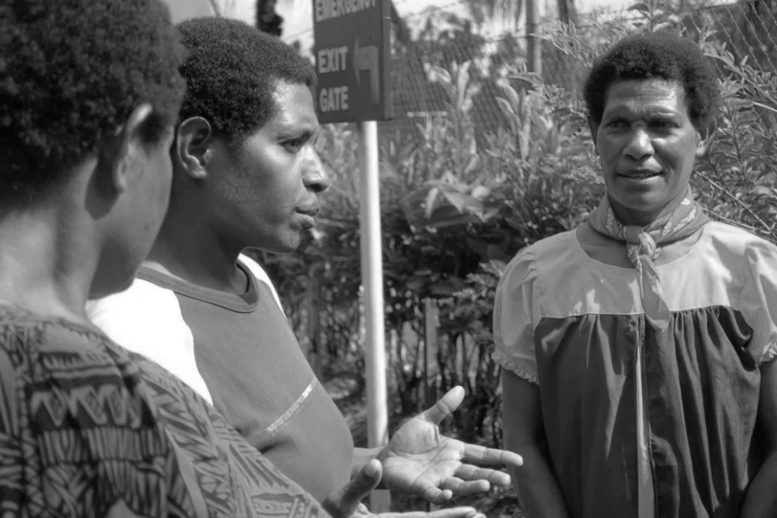

A good answer from a CDW is:

- This wok mak in the National Standard is: Use effective methods or techniques to mentor the mentees. Some methods or techniques are:

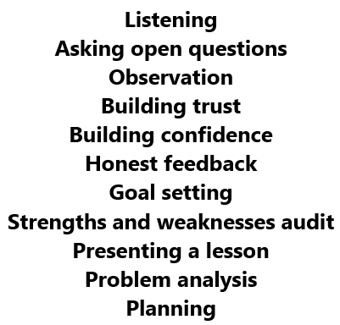

1 | Written answer  N  With your colleagues, discuss what you can do to adapt the mentoring to the mentees situation. Next, in your exercise book, write down this wok mak, and then write down the 8 things you can do to put this wok mak into practice (above).

A good answer from a CDW is:

- This wok mak in the National Standard is: Adapt the mentoring to the mentees situation. Eight things you can do to put this into practice are:
- Provide mentoring in the mentees own community (where they use what they learn).
- During community entry, find out from the key people what the mentees situation is like. Sindaun bilong ol istap olsem wanem?
- Find out the mentees education level, so that when you provide mentoring you mekim long level bilong ol. Never ever use jargon or ‘expensive’ English.
- Find out the language that the mentees like to use, so that when you provide mentoring you can do the mentoring in the right language. This might mean you will need to use a translator long tainim tok.
- Use good listening and good observation and ask open questions to find out from the mentees what their situation is like. Sindaun stap olsem wanem?
- Use examples or stories or tok piksa o tok bokis that will be familiar to the mentees
- Help the mentees to go through a learning from experience cycle. Focus on their own EXPERIENCE when you help them REFLECT and LEARN LESSONS and PLAN.
- When you give help or advice, ask the mentees how they can use it in their situation and what problems or challenges they might face (and what they can do about it).

3 | Written answer  O  In your exercise book, write down this wok mak, and then write down 5 things you want to do next time you mentor women to give them the extra support and encouragement they need.

A good answer from a CDW is:

- This wok mak in the National Standard is: Support and encourage effective participation and inclusion. Five things I want to do next time I mentor women to give them the extra support and encouragement they need are:
- Help women to feel comfortable, confident and respected.
- Have a woman mentor helping me
- Make sure the timing suits women
- Welcome babies and children
- Use inclusive language. Noken tok “man”, tok “manmeri”.

7 | Written answer  P  With your colleagues, discuss what you can do to overcome the three big challenges you might not think of when you mentor women (below). In your exercise book, write down the three big challenges, and then for each challenge, write down two things you can do to overcome each challenge.  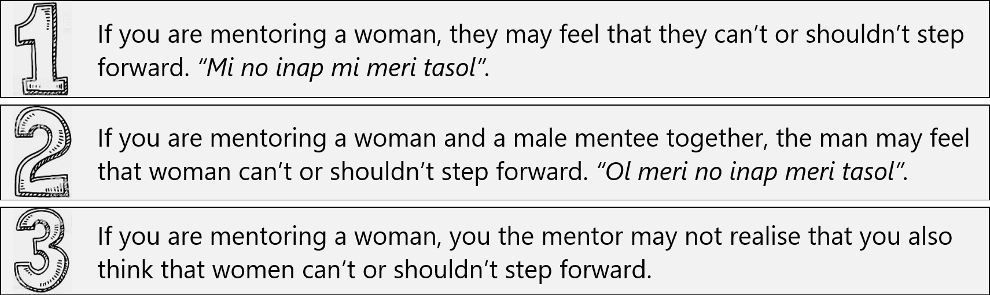

A good answer from a CDW is:

- Make it clear that mentoring works best if the mentees are involved and take the lead ino mata yu man o meri.
- Share stories where women have stepped forward – so that the woman mentees know that women can do it.

- Male sure the husband knows that women have a right to step forward. It is a human right. The PNG Government wants the kumul to fly with two wings.
- Share stories where husbands and wives have worked together and made

- When you provide mentoring, try your best to not be influenced by what you already think you know.
- Try and complete Gender Equity and Diversity training (GED).

4 | Written answer  Q  In your exercise book, write down this wok mak. Next, discuss with your colleagues what you should do to work in a way that is appropriate to local culture if you need to mentor someone of the opposite sex. When you have finished, write your answer in your exercise book.

A good answer from a CDW is:

- This wok mak in the National Standard is: Work in a way that is appropriate to local culture. If you need to mentor someone from the opposite sex, then when you make preparations (Element 1) and when you do community entry (Element 2), ask the leaders and key people what to do.

1 | Written answer  R  In your exercise book, write down this wok mak. Next, write down what it means to communicate effectively and with respect.

A good answer from a CDW is:

- This wok mak in the National Standard is: Communicate effectively and with respect. To communicate effectively means you need to get your message across to the mentees (and the mentees need to get their message across to you). To communicate with respect means you need to treat the mentees as equals.

2 | Written answer  S  In your exercise book, write down this wok mak. Next, write down five ways to find out if the mentees misunderstand or are confused.  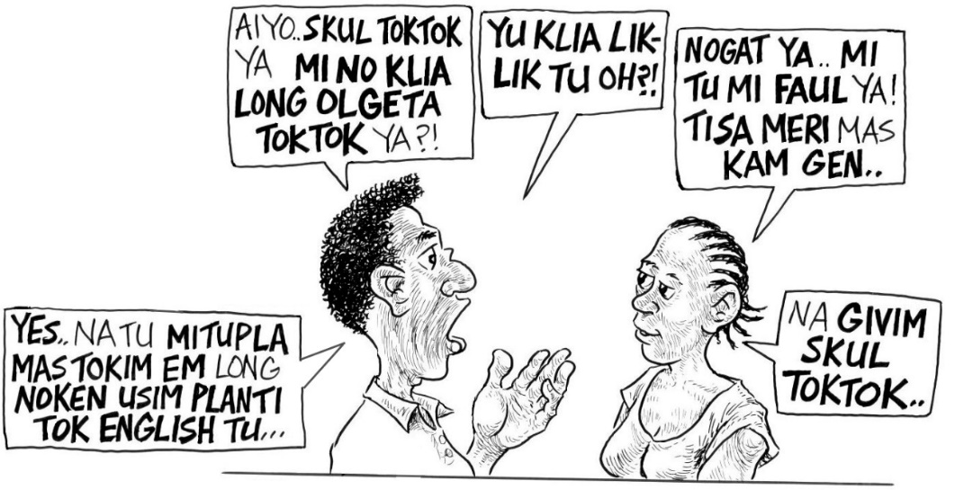

A good answer from a CDW is:

- This wok mak in the National Standard is: Respond to any misunderstanding or confusion while mentoring the mentees. Five ways to find out if the mentees misunderstand or are confused are:
- Ask the mentees if they are confused
- Ask the mentees some questions about the topic
- Check their non-verbal communication
- Tell the mentees that they can approach you or contact you any time
- Help the mentees feel comfortable, confident and respected

2 | Written answer  T  With your colleagues, discuss what you need to do to put this wok mak into practice. Next, in your exercise book, write down this wok mak.

A good answer from a CDW is:

- This wok mak in the National Standard is: Discuss what the next steps following the visit will be, and who to contact for further support or advice

5 | Written answer  U  With your colleagues, discuss what to do to put this wok mak into practice. Next, in your exercise book write down this wok mak. Next, write down two reasons why you think this wok mak is important to put into practice.

A good answer from a CDW is:

- This wok mak in the National Standard is: Discuss with the mentees whether the visit achieved its purpose, and ways it could be improved. Two reasons why this wok mak is important to put into practice are:
- It helps you (the mentor) to go through your own learning from experience cycle. So you become a better mentor (and a better Community Development Worker).
- The mentees get the chance to autim tingting na bel bilong ol. Giving the mentees a chance to autim bel shows that you respect them.

1 | Written answer  V  In your exercise book, write down the final wok mak you need to inapim if you want to provide mentoring in a way that meets the Standard.

A good answer from a CDW is:

- The final wok mak you need to put into practice to meet the Standard is: Thank the mentees, without rushing, and explain again what the visit has been for.

Written answer
W
Congratulations. You have finished CDW Coursebook 6. Time to evaluate CDW Coursebook 6. This is not a test. The purpose of these questions is for you (and your organisation and the course facilitator) to evaluate the learning experience that you have been through. With your colleagues, answer the questions below. Don’t forget to write your answers in your exercise book.

  - Which wok mak from CDW Unit C09 (Provide Mentoring) are you most confused about? What are you confused about?
  - What topic in the coursebook did you find the most useful? Why?
  - What change do you recommend to improve the course or the coursebook?
  - What advice can you give to the course facilitator to help them learn lessons?
  - What more support do you need from your organisation (or the course facilitator) to help you put what you have learned into practice?
  - Any other comments?
  - Use the rating scale below to rate overall how well you understand how to provide mentoring in a way that meets the National Standard? Decide which face lines up with how you feel, then look at the letter above that face (A, B, C, D, or E), and write that letter as your answer.

Sample written answers for CDW Coursebook 7

Below are the “written answer” questions from CDW Coursebook 7. Underneath each question is an example of a good answer. Don’t forget, this is not a test. If a CDW has made a mistake or has a different answer, then it doesn’t mean they have failed. If they have tried their best to answer every question, then fine. But you definitely need to give feedback to the CDW, so they learn from their mistakes. The best way to do this is to meet with them and go through their answers one by one. If you can’t meet with them, then give them feedback on the phone or online.

2 | Written answer  A  With your colleagues, write the coursebook objective on a poster na putim long ples klia. Leave it long ples klia until you complete this coursebook. For CDW Coursebook 7 (this coursebook) the objective is to Understand how to facilitate a specialist’s visit in a way that meets the Standard. Next, in your exercise book, write the coursebook objective and underline it (or circle it).

A good answer from a CDW is:

- Understand how to facilitate a specialist’s visit in a way that meets the Standard

4 | Written answer  B  With your colleagues, discuss what you would say to the specialist you are working with so that they know why it is important to support and encourage effective participation and inclusion during the activities. In your exercise book, write down three good points from your discussion.

A good answer from a CDW might include points like the following:

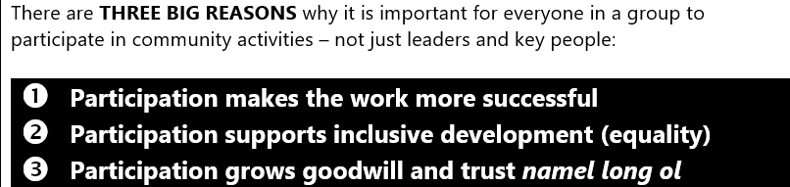

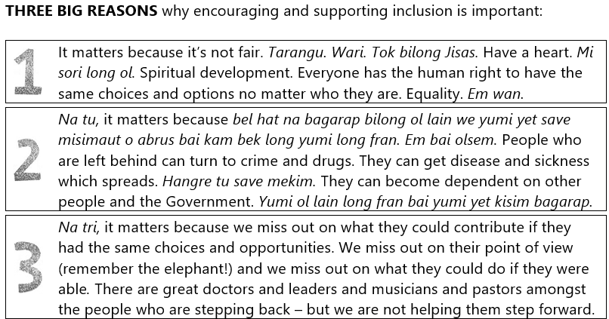

3 | Written answer  C  With your colleagues, discuss what you would say to the specialist and the key people so that they know why it is important to encourage key people to take the lead during the activities. In your exercise book, write down three good points from your discussion.

A good answer from a CDW will include three points like the following:

- By encouraging key people to take the lead, you build their confidence as leaders.
- By encouraging key people to take the lead, you help them understand why and how to be a Community Development Worker.
- By encouraging key people to take the lead, they will have more ownership of the work you are doing. This means the work you are doing will be more successful
- By encouraging key people to take the lead, everyone else in the group or the community will feel that they can also do it. You make everyone feel more powerful.
- By encouraging key people to take the lead you are showing respect – as long as you don’t force key people to take the lead. Rispek emi bikpela samting.

6 | Written answer  D  With your colleagues, discuss what you would say to the specialist so that they know why it is important to not use big words that are too complicated (“don’t use expensive English”). In your exercise book, write down two good points from your discussion.

A good answer from a CDW will include two points like the following:

- If the specialist doesn’t communicate effectively and respectfully then the relationship is broken between them and the community (and maybe also between you and the community).

- In PNG there is a big gap opening up between formally educated elites who know the jargon and expensive English (and like to show it) and the majority of people who don’t. You can help to close this gap by not using jargon and expensive words. If you do this then you will win the respect of everyone. Be humble.

3 | Written answer  E  With your colleagues, discuss what you would say to a specialist so that they know why it is important to work in a way that respects local culture. Next, in your exercise book write down two good points from your discussion.

A good answer from a CDW will include two points like the following:

- By working in a way that fits in with local kastom you will earn everyone’s respect, and your work will go better.

- If the specialist doesn’t work in a way that is appropriate to local culture, then the relationship is broken between them and the community (and maybe also between you and the community).

6 | Written answer  F  With your colleagues, discuss what could go wrong if the group or community don’t know how they might benefit from the work the specialist will be doing? Next, in your exercise book write down what could go wrong.

A good answer from a CDW will include points like the following:

- The group or community won’t support the specialist.
- The group or community might cause problems.
- Sections of parts of the group or community might cause problems.
- The relationship between you or the specialist and the group or community might be damaged.
- The group or community won’t give their consent for the visit to go ahead.

2 | Written answer  G  With your colleagues, discuss why some CDWs like to put the participants into small groups (man na meri na yut man na yut meri) to go through the details of the plan. Next, in your exercise book write down two good points from your discussion.

A good answer from a CDW will include two points like the following:

- CDWs know that some people in a kibung find it hard to speak up. It is a good idea to at least put everyone into a men’s group and a women’s group – tasol long mekim gut tru brukim igo long man na meri na yut man na yut meri.

- If more different groups of people (men, women, youth) have a chance to make suggestion, it is more likely you will have the full story (remember the elephant!) so the plan is a good plan. And it is more likely that each group (men, women, youth) will help and support when the work begins.

2 | Written answer  H  With your colleagues, discuss some reasons why a group or community might not give their consent to the specialist’s visit going ahead? Next, in your exercise book write down three good reasons.

A good answer from a CDW will include three good reasons like the following:

- They might want more details first before they are comfortable giving their consent to the visit going ahead.
- It might be that the community are worried about the visit causing problems with neighbouring communities – jealousy o kain olsem.
- It might be that there is a political dispute namel long ol.
- Or there might be that something else is happening in the community that means the visit would be disrespectful or inappropriate.
- Or it might be that people have safety or environmental concerns.

2 | Written answer  I  With your colleagues, discuss the roles of the CDW, the specialist, the key people, and everyone else in the group or community. Next, write down everyone’s roles (below) in your exercise book.

A good answer from a CDW will be:

 | The role of a CDW during a specialist’s visit is to make sure the key people and their group or community stay IN CONTROL.
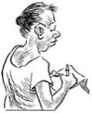 | The role of the specialist is to collect information in a way which makes sure the key people and their group or community stay IN CONTROL.
 | The role of key people is to assist the CDW and the specialist and to represent the interests of their group or community.
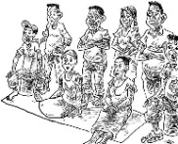 | The role of everyone in the group or community is to cooperate with their key people, the CDW, and the specialist.

5 | Written answer  J  The role of a CDW during a specialist’s visit is to work in a way that meets the National Standard, so that the key people and their group or community are IN CONTROL. In your exercise book write down the four things you need to do so that the key people and their group or community are IN CONTROL (below). Don’t forget, these four things are also wok mak in the National Standard.

A good answer from a CDW will be:

 | Understand the purpose of the specialist’s visit, what information needs to be collected, how it will be used, and how the group or community might benefit.
 | Review the plan for collecting the information and the methods and equipment that will be used.
 | Give their consent for the specialist’s visit to go ahead. Wanbel.
 | Discuss roles and expectations. Who will do what. Who expects what?

3 | Written answer  K  A specialist has planned to collect water samples from different water sources to test how clean the water is (as part of a water-supply project). There has been a landslide, and the specialist will need to cross the landslip to reach the water source. It looks dangerous. What shoud the CDW recommend? Discuss this with your colleagues. Next, in your exercise book, write down what you would recommend.

A good answer from a CDW will include some of the recommendations below:

- Don’t cross the landslide.
- Talk to key people to find out what to do or see if there is another route.
- With the specialist, contact a Line Manager to get their thoughts.

4 | Written answer  L  Earlier in this topic you learned that facilitating a specialist’s visit is like a sandwhich. Ino olsem tasol wankain. In your exercise book, write down or draw how facilitating a specialist’s visit is like a sandwhich.

A good answer from a CDW will something like below:

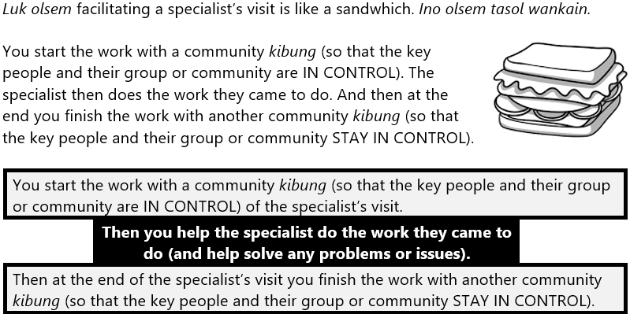

Written answer
M

For the key people and their group or community to STAY IN CONTROL everyone needs to:

Be involved with addressing any problems of issues while the information is being collected.

Know what the specialist found out and have a chance to ask questions.

Know what the next steps following the visit will be, who will be responsible for making them happen, and who to contact for more information.

In your exercise book write down the three things you need to do so that the key people and their group or community STAY IN CONTROL. Don’t forget, these three things are also wok mak in the National Standard nau tasol yumi lukim.

A good answer from a CDW will be:

Be involved with addressing any problems of issues while the information is being collected.

Know what the specialist found out and have a chance to ask questions.

Know what the next steps following the visit will be, who will be responsible for making them happen, and who to contact for more information.

3 | Written answer  N  All Community Development Workers need to maintain a record of activities and movements according to workplace practices. This is a wok mak that you need to inapim if you want to prepare a report in a way that meets the Standard. You learned about how to prepare a report in a way that meets the Standard in CDW Coursebook 1. Discuss with your colleagues what sort of information would be in your diary or journal after facilitating a specialist’s visit? Next, in your exercise book, write down five things that would probably be in your diary or journal after facilitating a specialist’s visit.

A good answer from a CDW will include five answers like the following:

- What activities you did
- Your observations
- Stories and comments that were made
- Times and dates
- Numbers of participants
- Lessons learned
- Comments made about how useful the visit was and ways it could be improved
- Next steps and who will be making them
- Contact details for the key people
- Initial results from the specialist’s work
- Evidence to know if the expected outcomes were achieved

1 | Written answer  O  In your exercise book, write down the final wok mak you need to inapim if you want to facilitate a specialist’s visit in a way that meets the Standard.

A good answer from a CDW is:

- Thank the group, without rushing, and explain again the purpose of the visit

Written answer
P
Congratulations. You have finished CDW Coursebook 7. Time to evaluate CDW Coursebook 7. This is not a test. The purpose of these questions is for you (and your organisation and the course facilitator) to evaluate the learning experience that you have been through. With your colleagues, answer the questions below. Don’t forget to write your answers in your exercise book.

  - Which wok mak from CDW Unit C10 (Facilitate a Specialist’s Visit) are you most confused about? What are you confused about?
  - What topic in the coursebook did you find the most useful? Why?
  - What change do you recommend to improve the course or the coursebook?
  - What advice can you give to the course facilitator to help them learn lessons?
  - What more support do you need from your organisation (or the course facilitator) to help you put what you have learned into practice?
  - Any other comments?
  - Use the rating scale below to rate overall how well you understand how to facilitate a specialist’s visit in a way that meets the National Standard? Decide which face lines up with how you feel, then look at the letter above that face (A, B, C, D, or E), and write that letter as your answer.

certificate of COURSE completion




Awarded to ______________________________
For completing the Community Development Worker course
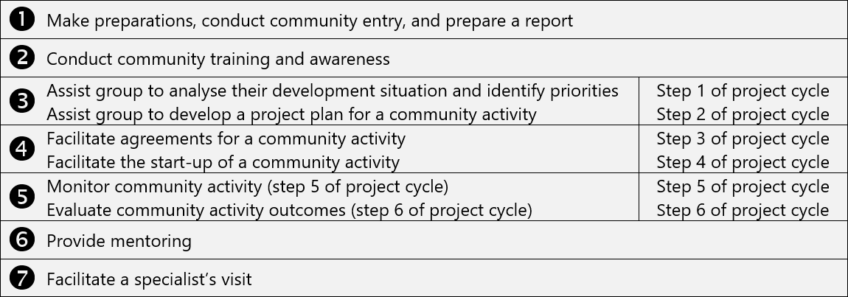

Signature of course facilitator
Name of course facilitator and date

