**Duty Statement: Community Awareness Officer**

**Officer: Damage Sausage**

When you work with communities and groups, our organisation expects you to work in a way that meets the National Standard for Community Development Workers. We will provide training and other forms of support to help you to do it. We will also provide opportunities for assessment and accreditation against the National Standard, should you wish.

The National Standard for Community Development Workers was set up by expert PNG Community Development Workers. It is endorsed by the PNG Government under the auspices of the National Apprenticeships and Trade Testing Board. Our organisation is using the National Standard to provide professional development opportunities for our officers, and to improve the development assistance we provide to the communities and groups that we work with. Our organisation also wants to be able to prove that we are working in a way that meets the PNG National Standard for Community Development Workers so that we continue to attract funding from donor organisations.

When you conduct awareness, put the following performance criteria *(wok mak)* into practice.

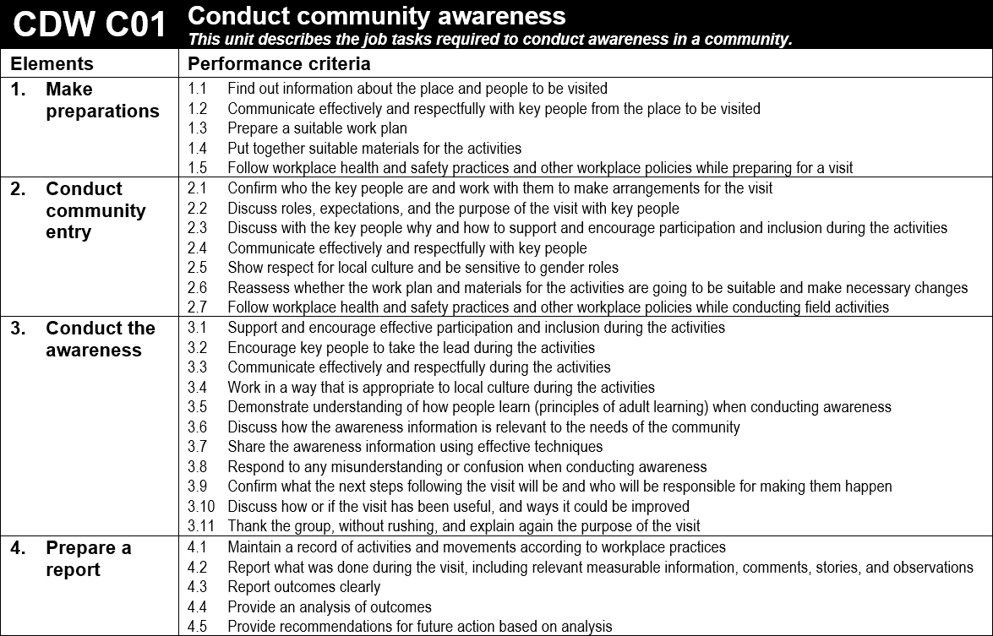

When you facilitate an agreement, put the following performance criteria *(wok mak)* into practice.

Signatures:

I agree to support this officer, so that they have opportunities to perform their duties

_________________________________

Line Manager

I agree to perform my duties as described

_________________________________

Damage Sausage